Ethanol as a Marine Fuel: Advantages, Consequences and Availability
Ethanol is an alternative fuel being considered for the marine industry as shipping companies look for ways to reduce greenhouse-gas emissions and dependence on conventional marine fuels such as heavy fuel oil (HFO), marine gas oil (MGO) and very-low-sulphur fuel oil (VLSFO).
For shipowners and technical superintendents, the important questions are whether ethanol can be used in existing marine diesel engines, how safe and economical it is, whether it reduces emissions, and whether it is readily available at major bunkering ports.
1. What is ethanol fuel?
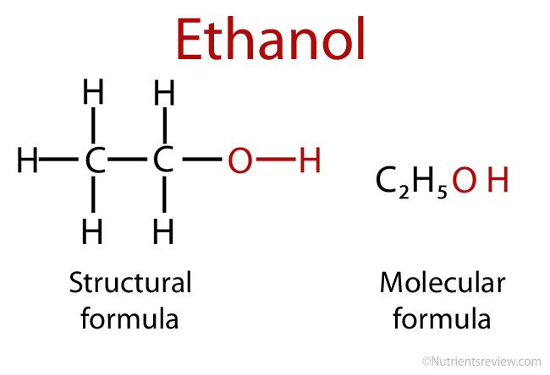
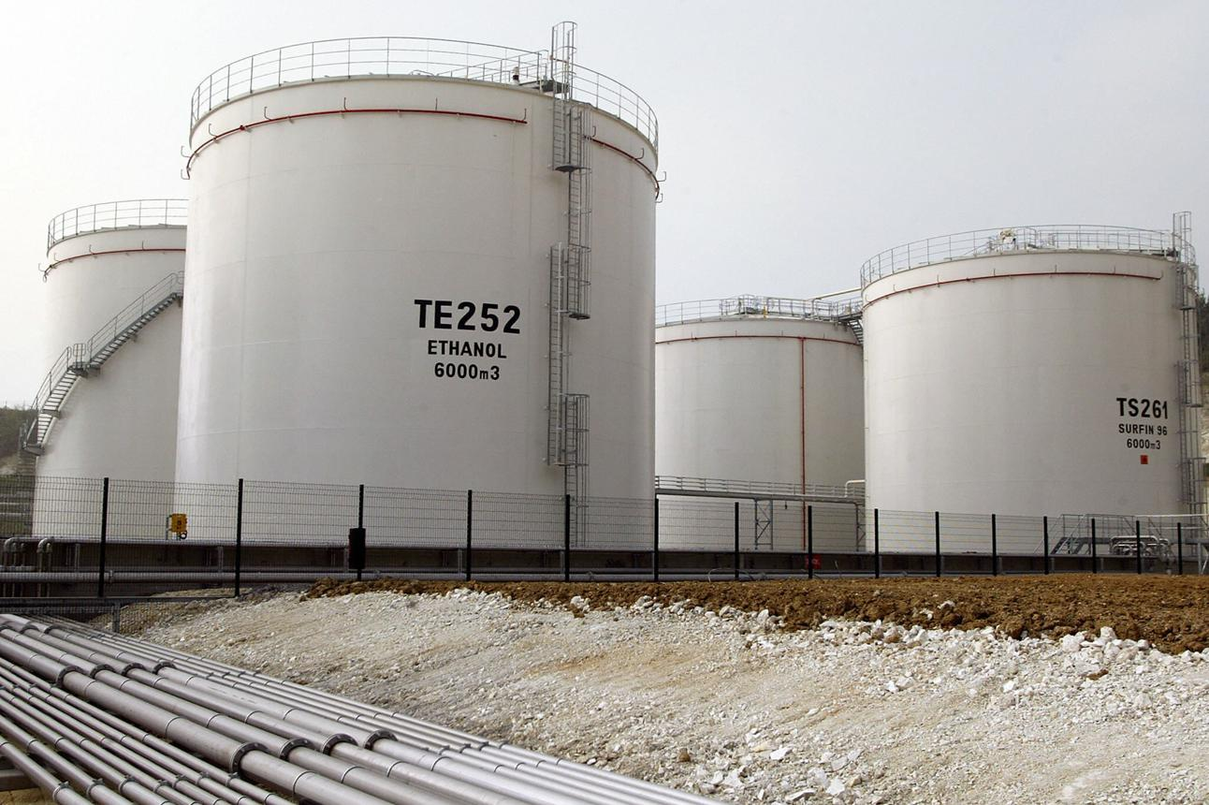
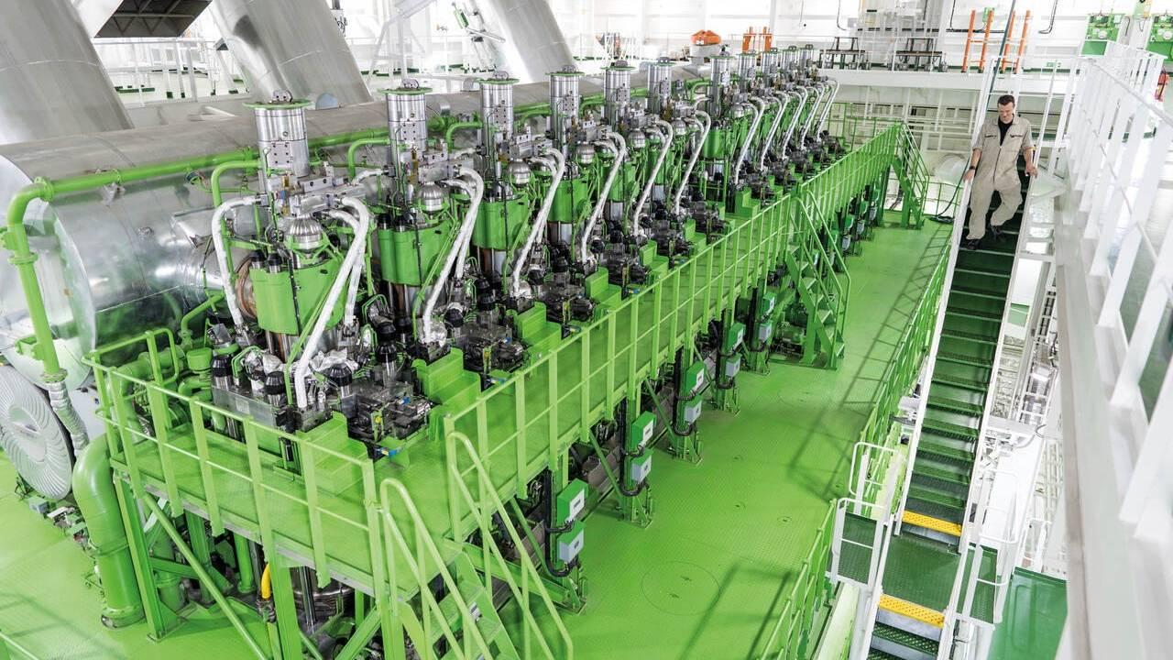
7
Ethanol, also known as ethyl alcohol, is a liquid fuel with the chemical formula as mentioned earlier. It can be produced by fermenting biomass containing sugars or starch, or through other chemical production routes.

There are two important categories:
- Bioethanol: Produced from feedstocks such as sugarcane, corn, molasses and agricultural residues.
- Synthetic ethanol: Produced through chemical pathways, potentially using renewable electricity-derived hydrogen and captured carbon dioxide.
The environmental benefit depends heavily on how the ethanol is produced. Ethanol made using low-carbon energy and sustainable feedstocks can offer substantial lifecycle greenhouse-gas reductions; ethanol produced using fossil-intensive energy may deliver much smaller benefits.
2. How can ethanol be used onboard a ship?
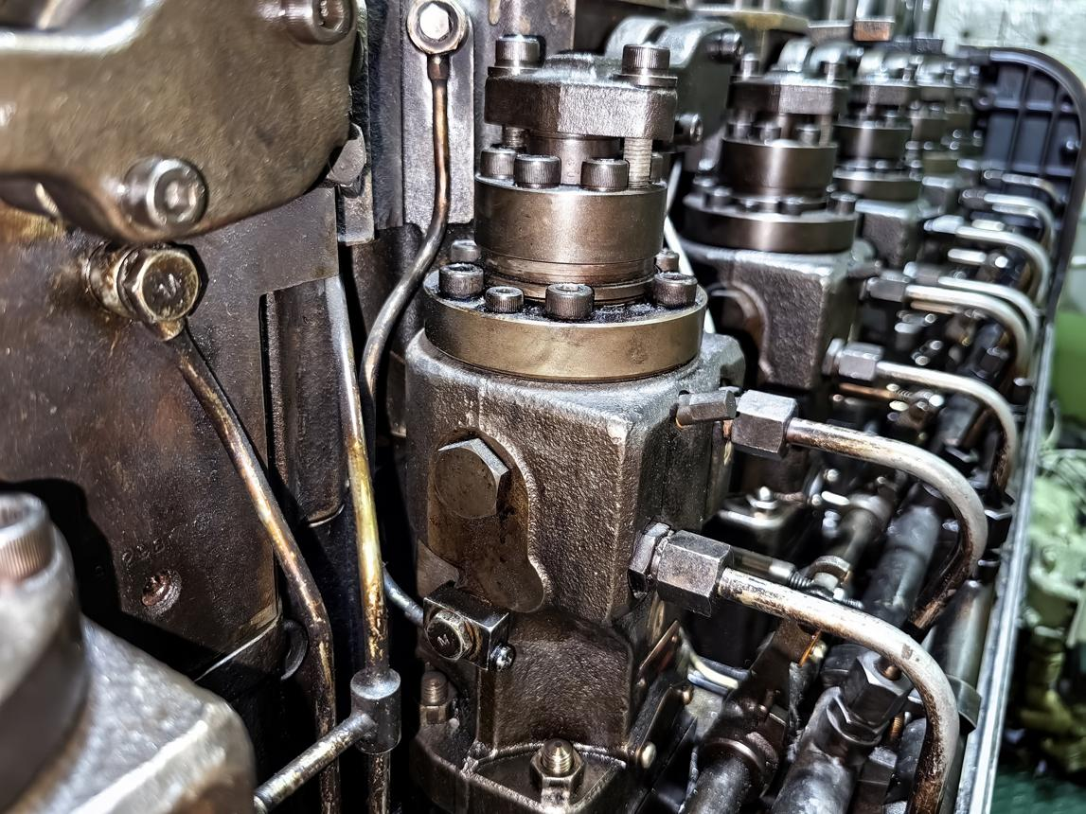
A. Modified internal-combustion engine
Ethanol can be used in specially designed or modified engines. Because its ignition characteristics differ significantly from diesel fuel, a conventional compression-ignition engine generally cannot simply switch to pure ethanol without suitable engine modifications or an ignition-assistance system.
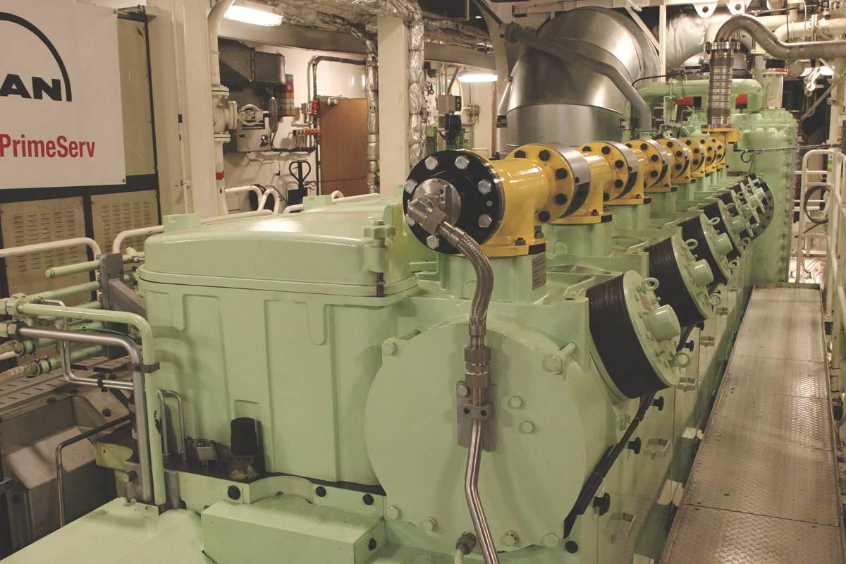
B. Dual-fuel operation
A purpose-designed engine may use ethanol as the main fuel with a pilot quantity of diesel or another suitable ignition fuel. The engine, fuel injection system and controls must be designed for the selected fuel arrangement.
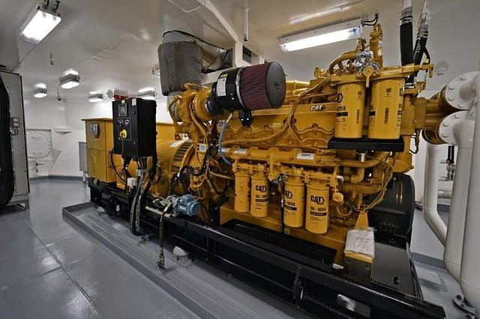
C. Auxiliary power and smaller vessels
Ethanol may be considered for auxiliary engines, workboats and other vessels where fuel consumption, operating patterns and bunkering arrangements make the technology practical.
Important engineering point: Ethanol is not a direct drop-in replacement for marine diesel oil in a conventional ship engine. Any conversion requires maker approval, a suitable fuel system, risk assessment and applicable class and flag acceptance.
3. Advantages of ethanol as a marine fuel
1. Potential reduction in lifecycle CO₂ emissions
Bioethanol can reduce total greenhouse-gas emissions when its feedstock, cultivation, processing and transportation have a low carbon footprint. The reduction is not automatic: fossil-intensive production can significantly reduce the environmental benefit.
2. Lower sulphur oxide and particulate emissions
Ethanol contains oxygen and essentially no sulphur when properly specified. Its use can therefore reduce SOx and particulate emissions compared with conventional sulphur-containing marine fuels. Actual NOx and other emissions depend on engine design and operating conditions.
3. Established production industry
Ethanol is already manufactured in large quantities for road transport, industrial use and other markets. This provides a potential supply base that can be adapted to marine applications, subject to fuel-quality requirements and distribution logistics.
4. Liquid at normal ambient conditions
Unlike liquefied natural gas, ethanol does not require cryogenic storage. It can be stored as a liquid in appropriately designed tanks, which can simplify some aspects of fuel handling.
5. Fuel diversification
Ethanol offers another potential pathway for shipowners seeking to reduce dependence on fossil fuels. A suitable dual-fuel engine can also retain an alternative fuel option, depending on its design and approval.
These benefits are consistent with marine alternative-fuel assessments, but lifecycle emissions and actual engine performance must be evaluated for the specific fuel pathway and vessel.

4. Disadvantages and consequences
The following issues are especially important for the Chief Engineer, technical superintendent and shipowner.
Technical factor | Consequence onboard
Lower energy content | More fuel is needed for the same energy output.
Poor compression-ignition characteristics | A conventional diesel engine generally needs modification or pilot ignition to use ethanol reliably.
Low viscosity and different lubricating properties | Fuel pumps, injectors, seals and other components need compatible designs.
Water affinity | Water contamination can affect fuel quality and may cause phase or material-compatibility issues, depending on composition and conditions.
Material compatibility | Tanks, coatings, seals, piping and pumps must be checked for ethanol service.
Fire risk | Ethanol has a low flash point and can ignite readily; dedicated detection, ventilation, isolation and firefighting arrangements are needed.
Lower volumetric energy density | Larger tank capacity or more frequent bunkering may be required.
Feedstock and production variability | The lifecycle carbon benefit and cost depend on production method and certification.
The energy-density problem
A key disadvantage is that ethanol contains substantially less energy per litre than conventional marine diesel fuel.
Approximate energy content by volume
Heating-value comparison; actual values vary with fuel specification and temperature.
Fuel Type | Lower Heating Value (LHV / Net)  by Mass (MJ/kg) | Lower Heating Value (LHV / Net)  by Volume (MJ/L) | Higher Heating Value (HHV / Gross)  by Mass (MJ/kg) | Higher Heating Value (HHV / Gross)  by Volume (MJ/L)
Diesel Fuel | 42.6 | 36.0 | 45.6 | 38.6
Ethanol (100%) | 26.8 | 21.1 | 29.7 | 23.4
Methanol | 19.9 | 15.8 | 22.7 | 17.9

Using these approximate values, ethanol would require about 1.63 times the liquid volume of diesel to supply the same amount of fuel energy, assuming comparable conversion efficiency.
For example, if a vessel consumes 20 tonnes of diesel per day, the equivalent ethanol mass would be roughly 31–32 tonnes per day based on lower heating value alone. This is an energy-equivalence estimate, not a guaranteed engine consumption figure.
For a deep-sea tanker or bulk carrier, this can affect:
- Bunker tank capacity and cargo space.
- Voyage range and fuel reserve planning.
- Bunker frequency and port-call scheduling.
- Fuel transfer rates and operating costs.

Fire and personnel safety
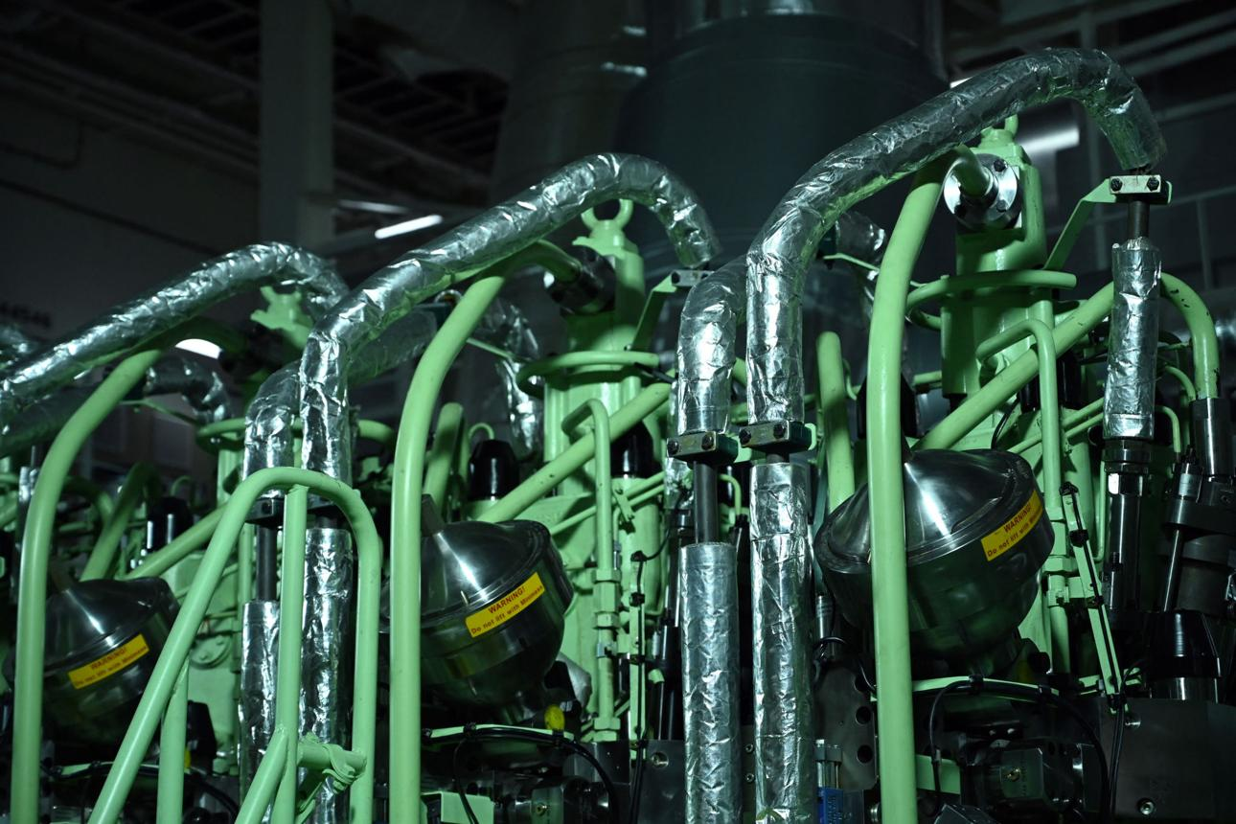
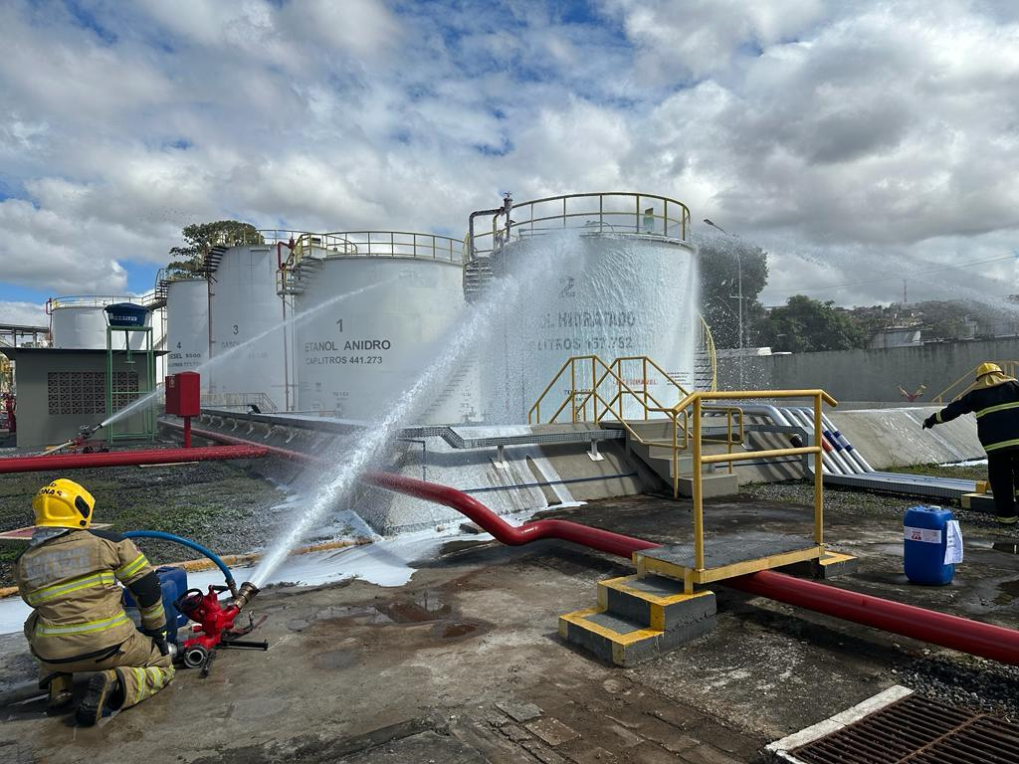
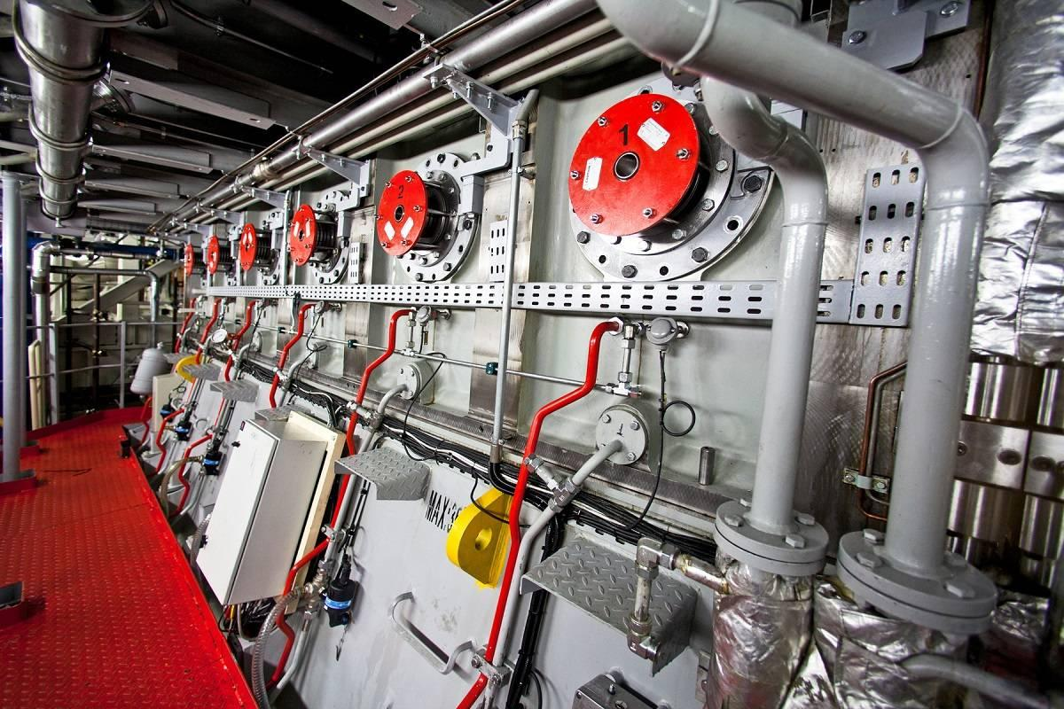

Ethanol has a flash point around 13°C, so its vapour can present a serious ignition hazard under normal shipboard ambient conditions. Although ethanol flames are generally more visible than methanol flames, detection and firefighting still require appropriate equipment and procedures.

For a vessel conversion, the safety review should cover:
- Fuel tank segregation, ventilation and hazardous-area classification.
- Double-wall piping or equivalent leak-containment arrangements where required by the approved design.
- Gas/vapour detection, emergency shutdowns and remote isolation.
- Suitable electrical equipment and ignition-source control.
- Fuel spill containment and approved firefighting arrangements.
- Crew training, bunkering procedures and emergency drills.
Regulatory note: The IMO's interim guidelines for ships using methyl/ethyl alcohol as fuel provide an important starting point, but the actual design must be accepted by the flag Administration and classification society for the vessel and fuel arrangement concerned.

5. Availability of ethanol in the marine industry — October 2026
The position has changed significantly during 2026. Ethanol is no longer only a research topic; commercial bunkering and sea trials have demonstrated that it can be supplied to appropriately equipped ships.
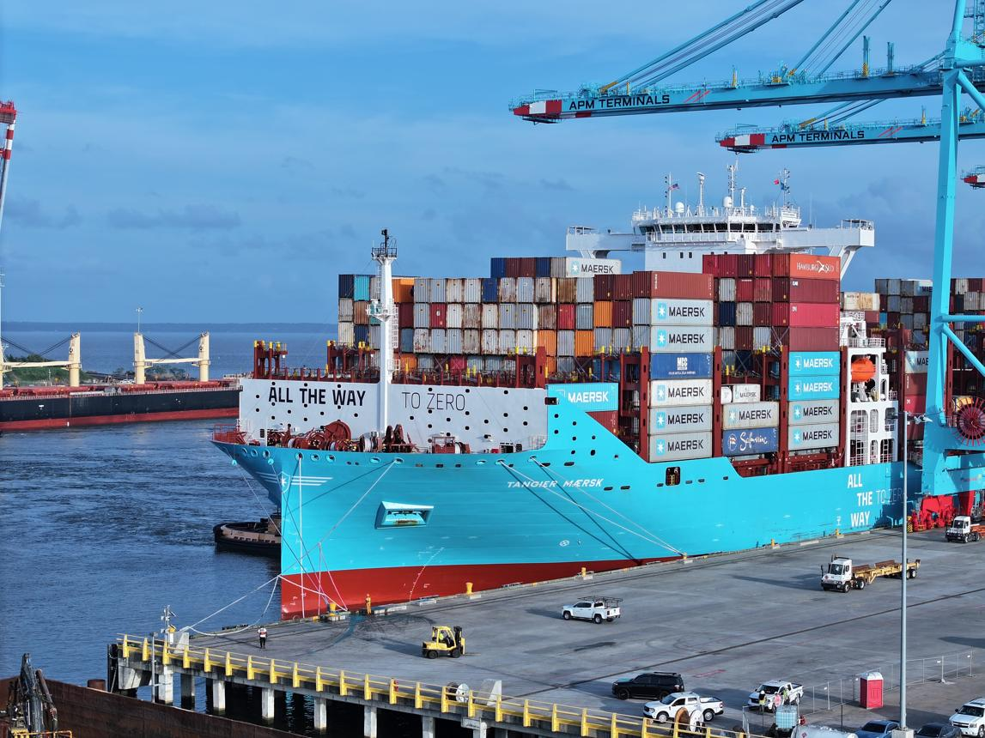
Singapore — October 2026
Commercial milestone
Approximately 5,000 tonnes of certified bioethanol were bunkered to Maersk Halifax. Singapore reported this as the largest single ethanol bunkering operation to date.

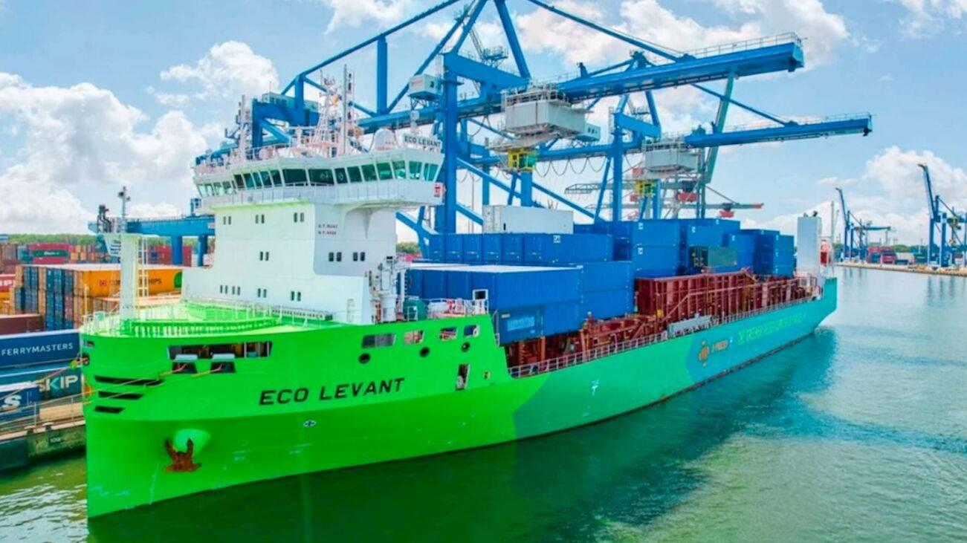
Rotterdam, Netherlands — May 2026
The container ship Eco Levant received a fuel blend comprising 90% certified biomethanol and 10% certified second-generation ethanol. The fuels were bunkered separately and blended onboard.

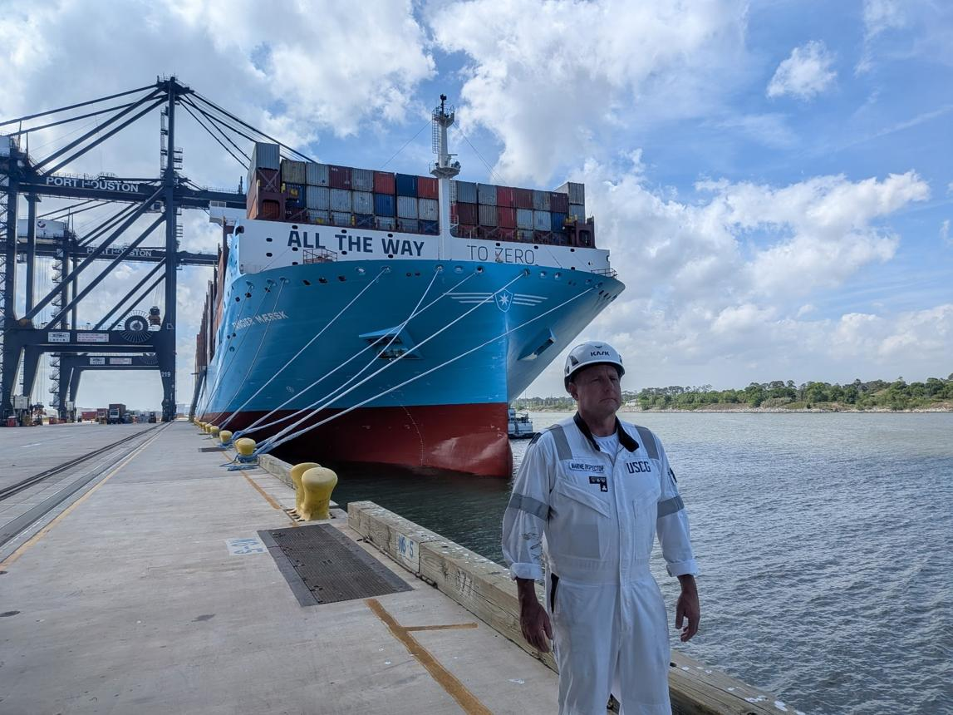
United States — September 2026
Tangier Maersk completed commercial ship-to-ship bunkering using US-produced corn ethanol, demonstrating another supply route for deep-sea shipping.

What is happening in India?
India has a substantial ethanol-production industry, using feedstocks such as sugarcane, molasses, maize and other grains. Government reporting in 2026 indicates production capacity of nearly 20 billion litres annually.

Press Information Bureau
However, three different types of availability must be distinguished:
- Ethanol production: Well established in India.
- Industrial and road-fuel distribution: Established, with extensive infrastructure for petrol blending.
- Certified marine-grade ethanol bunkering: A separate requirement involving suitable fuel specifications, quality assurance, dedicated supply arrangements, and compatible ship systems.
I could not verify a regular, publicly established ethanol-bunkering service for ocean-going ships at Chennai, Mumbai, or other Indian ports as of October 2026. That does not rule out private supply arrangements, but a shipowner should obtain written confirmation of marine-grade fuel availability, quantity, quality and delivery capability before planning a voyage around it.
India's ethanol production capacity could create an opportunity for domestic marine-fuel suppliers, provided the necessary standards, commercial demand and bunkering infrastructure develop.
6. Can ethanol compete economically with conventional marine fuels?
Fuel price per tonne alone is misleading because ethanol provides less energy per tonne and per litre than marine diesel.
Parameter | Ethanol | Conventional marine diesel
Fuel price per tonne | Depends on grade, origin and certification | Depends on port and market
Energy per tonne | Lower | Higher
Fuel volume required | Higher | Lower
Engine conversion cost | Potentially significant | Existing system
Carbon reduction | Depends on lifecycle pathway | Fossil fuel baseline
Supply network | Emerging for marine use | Globally established
A proper economic assessment should calculate the cost per unit of useful energy, then add engine efficiency, conversion capital expenditure, tank modifications, crew training, certification and fuel availability.
For example, if ethanol costs 70% of the diesel price per tonne, but approximately 1.55 times as much ethanol is needed by mass to provide equivalent fuel energy,
That means ethanol would cost approximately 8.5% more for the same energy input, before accounting for differences in engine efficiency or other costs.
Ethanol can nevertheless become competitive when the fuel is inexpensive, lifecycle emissions have economic value, or regulations favour low-carbon fuels. Commercial viability remains dependent on the specific supply chain and engine configuration.

7. Ethanol versus methanol as marine fuels
Approximate properties; actual values depend on fuel specification.
Property | Ethanol | Methanol
Chemical formula | C₂H₅OH | CH₃OH
Lower heating value by mass | 26.8 MJ/kg | 19.9 MJ/kg
Energy per litre | About 21 MJ/L | About 16 MJ/L
Flash point | About 13°C | About 11°C
Compression ignition | Requires special arrangements | Requires special arrangements
Marine adoption | Emerging | More established, though still developing
Storage | Liquid at ambient conditions | Liquid at ambient conditions
Ethanol has higher energy content than methanol, so it generally requires less storage volume than methanol for the same fuel energy. Both require careful attention to fire safety, material compatibility, engine technology and lifecycle emissions.

8. What should a ship-management company evaluate before adopting ethanol?
For a tanker, bulk carrier or DP vessel, I would recommend the following technical review before considering an ethanol conversion.
- Engine-maker confirmation: Obtain written confirmation that the engine can operate on ethanol, either as a dedicated fuel or in an approved dual-fuel arrangement.
- Fuel-system assessment: Review injection pumps, injectors, seals, piping, tank coatings, filtration and fuel conditioning.
- Tank-capacity assessment: Calculate the additional fuel volume required for the intended voyage and reserve requirements.
- Safety and class approval: Complete the fuel-risk assessment, fire-protection review, hazardous-area assessment and flag/class approval process.
- Fuel procurement: Confirm sustainable fuel certification, specification, supplier reliability and delivery at every intended bunker port.
- Commercial feasibility: Compare five-year total ownership and operating costs against conventional fuels and other alternatives such as methanol, biofuels and LNG.
Conclusion
Ethanol is a promising alternative marine fuel with potential environmental benefits, established production capacity and increasingly demonstrated commercial bunkering capability. The major milestones in Singapore, Rotterdam and the United States during 2026 show that the industry is moving beyond laboratory trials.
However, ethanol is not yet a universal replacement for conventional marine diesel. Lower energy density, engine compatibility, safety requirements, lifecycle emissions and marine bunkering availability remain important considerations.
For India, the opportunity is particularly interesting because of its large domestic ethanol-production base. The next step is to establish certified marine-fuel supply chains and demonstrate technical and economic viability on suitable vessels.
The most important principle for a manage is this: evaluate the entire fuel pathway—from production and bunkering to engine performance and lifecycle emissions—not merely the fuel price or the emissions at the ship's exhaust.

