Carbon Capture and Storage (CCS) in the Marine Industry
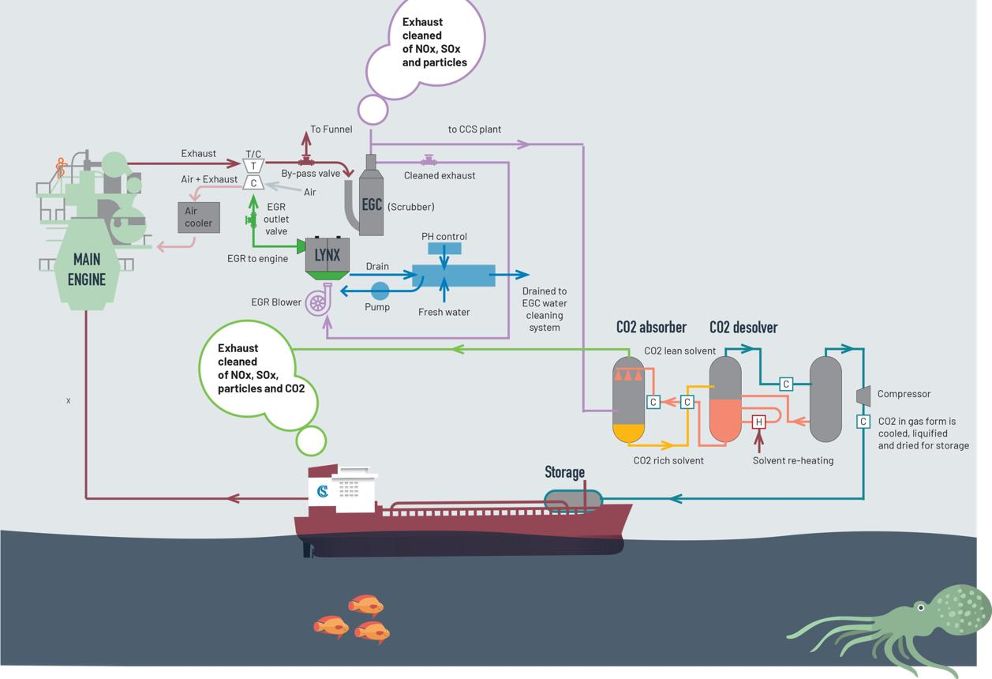
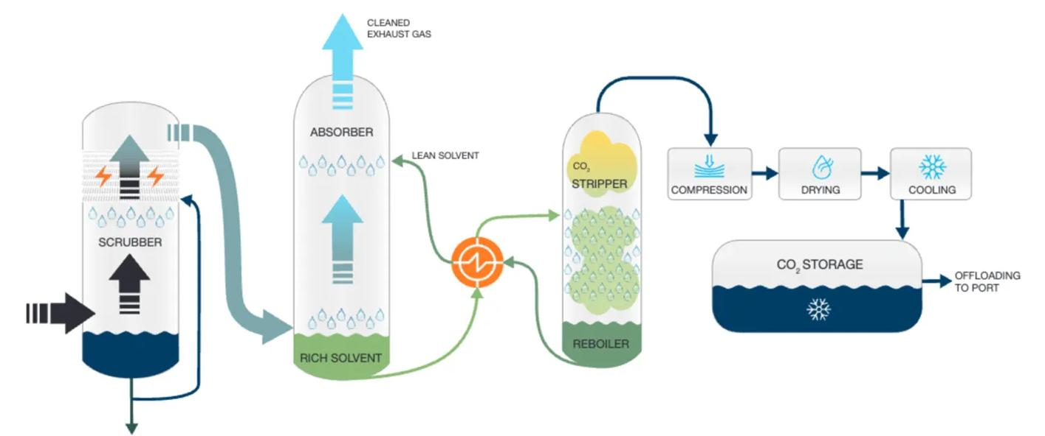
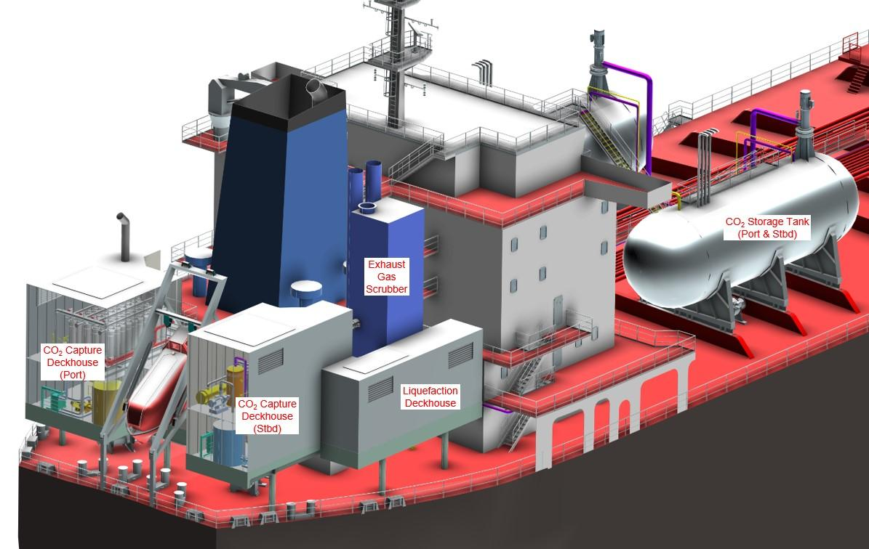

1. Introduction: Why Was CCS Introduced in the Marine Industry?
CCS stands for Carbon Capture and Storage. It is an emerging technology being explored to help the shipping industry reduce carbon dioxide (CO₂) emissions, particularly from ships that continue to use conventional carbon-based marine fuels.
Marine diesel engines and boilers burn fuels such as heavy fuel oil (HFO), marine diesel oil (MDO), and, in the case of gas engines, liquefied natural gas (LNG). During combustion, the carbon in these fuels combines with oxygen to form CO₂, a greenhouse gas that contributes to global warming.
Even when a modern marine engine achieves high thermal efficiency, it continues to produce CO₂ as long as it burns carbon-containing fuel. Improvements in engine design, combustion, turbocharging, and waste-heat recovery can reduce fuel consumption, but they cannot eliminate CO₂ emissions completely.
CCS aims to capture a portion of this CO₂ before it is released into the atmosphere and retain it for subsequent storage or suitable use.

Why does the marine industry need CCS?
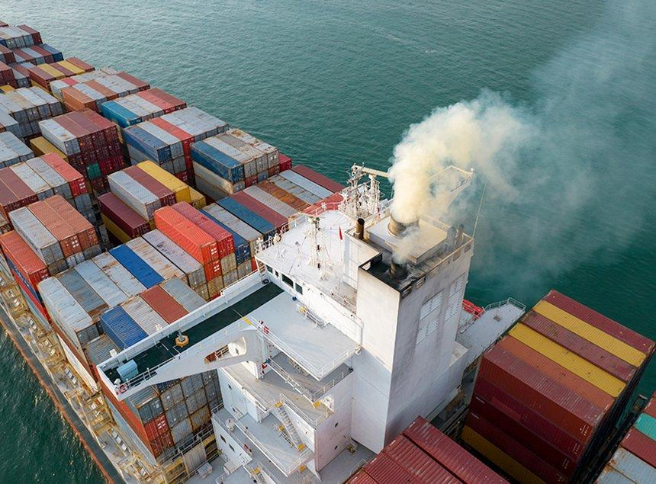
1. Reduction of greenhouse gas emissions
Ships consume large quantities of fuel during long voyages. Capturing CO₂ from engine exhaust can reduce the amount of greenhouse gas released directly into the atmosphere.
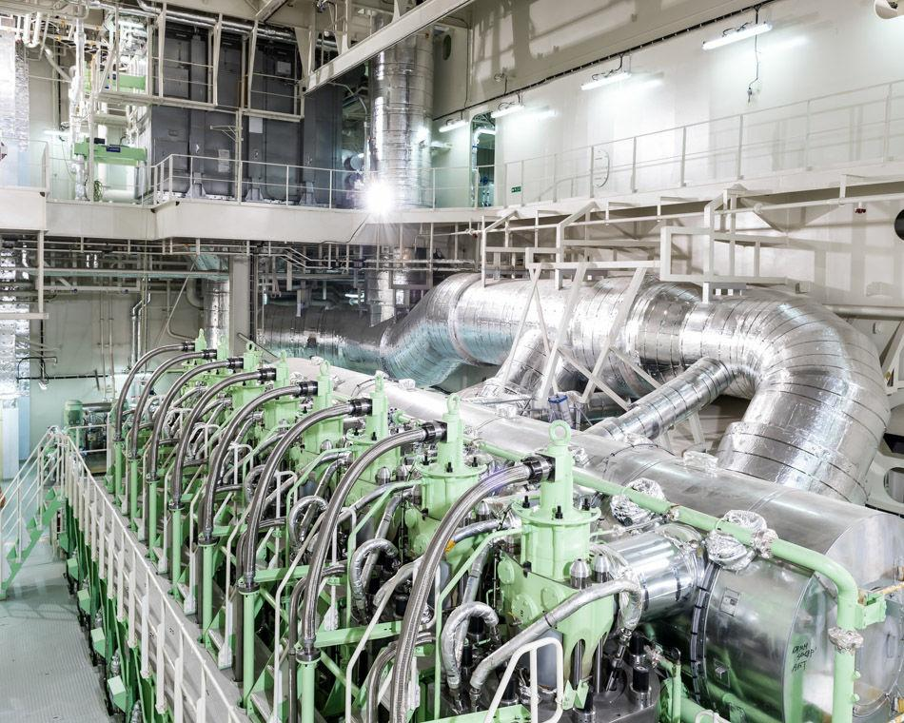
2. Limitations of conventional marine fuels
Improving engine efficiency reduces fuel consumption and CO₂ emissions, but it does not eliminate them while carbon-based fuels are being burned. CCS offers an additional emissions-reduction option.

3. International decarbonisation targets
The International Maritime Organization (IMO) adopted its 2023 greenhouse-gas strategy, aiming for net-zero greenhouse-gas emissions from international shipping by or around 2050, with interim checkpoints for 2030 and 2040. CCS is being investigated as one potential supporting technology.
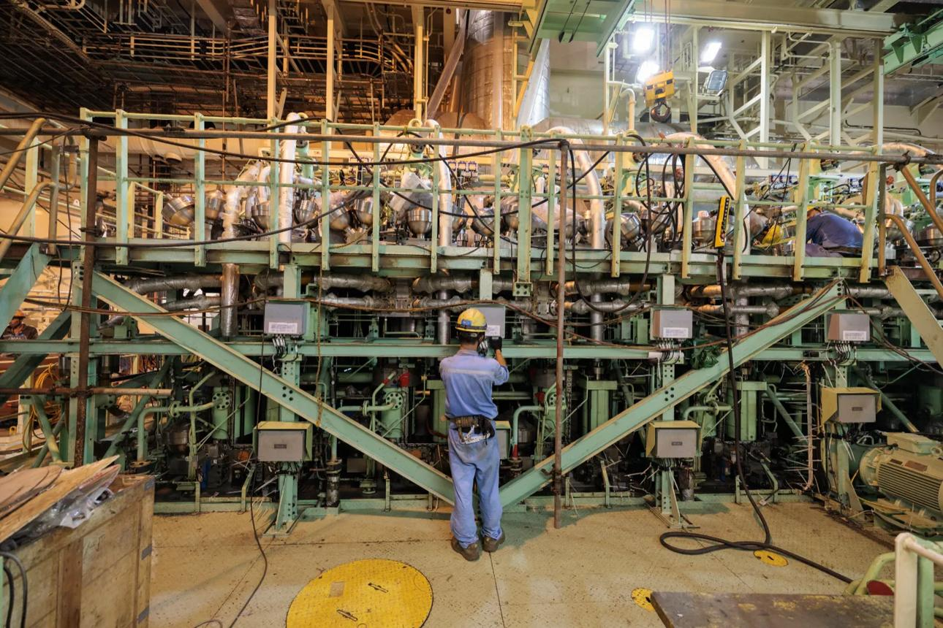
4. Potential use on existing ships
A suitable vessel may be retrofitted with an exhaust-gas capture plant without replacing its main engine. However, feasibility depends on available space, weight allowance, energy supply, stability, operating profile, and access to shore-side CO₂ reception facilities.
2. What Is a Carbon Capture and Storage System?
A Carbon Capture and Storage system is designed to separate CO₂ from an exhaust stream or another industrial process, condition it for handling, transport it, and ultimately store it for long-term isolation from the atmosphere.
In shipboard applications, the system may capture CO₂ from the exhaust of the main engine, auxiliary engines, and potentially boilers, depending on its design.
The process has three main stages:
- Capture: Separate CO₂ from exhaust gas.
- Transport: Transfer the captured CO₂ to a suitable storage or reception facility.
- Storage: Store it in a manner intended to prevent its release back into the atmosphere, commonly through permanent geological storage.
Captured CO₂ may also be used in industrial applications. However, utilisation is not automatically equivalent to permanent storage: the climate benefit depends on the application, energy consumed, and how long the carbon remains out of the atmosphere.
3. How Does a Carbon Capture System Work Onboard a Ship?

The following is a simplified operating sequence for a shipboard post-combustion carbon capture system.
Step 1 — Exhaust gas from the engine
The main engine, auxiliary engine, or boiler burns fuel and produces exhaust gas containing CO₂, nitrogen, water vapour, and other combustion products.
Step 2 — Exhaust gas conditioning
The exhaust is cooled and conditioned to meet the requirements of the capture plant. Depending on the design, additional treatment may be required to control soot, sulphur compounds, and other contaminants that could affect the capture solvent.
Step 3 — CO₂ separation in the absorber
The conditioned exhaust gas passes through an absorber, where a chemical solvent, commonly an amine-based solution, absorbs CO₂. The remaining gas, with reduced CO₂ content, is discharged through the exhaust system.
Step 4 — Solvent regeneration and CO₂ recovery
The CO₂-rich solvent is heated in a regeneration unit, often called a stripper. The heat releases the CO₂, and the regenerated solvent returns to the absorber for reuse.
Step 5 — CO₂ compression and liquefaction
The recovered CO₂ is conditioned, compressed and, where required, cooled to a suitable liquid-storage condition. Moisture and impurities must be controlled to meet the relevant transport and storage specifications.
Step 6 — Onboard storage and shore-side unloading
The captured CO₂ is held in specially designed tanks and later transferred to a reception facility. It can then be transported for permanent geological storage or sent for an appropriate industrial use.
Note: The actual process, equipment arrangement, and operating pressures and temperatures vary with the capture technology and vessel design.
4. Main Equipment Required Onboard
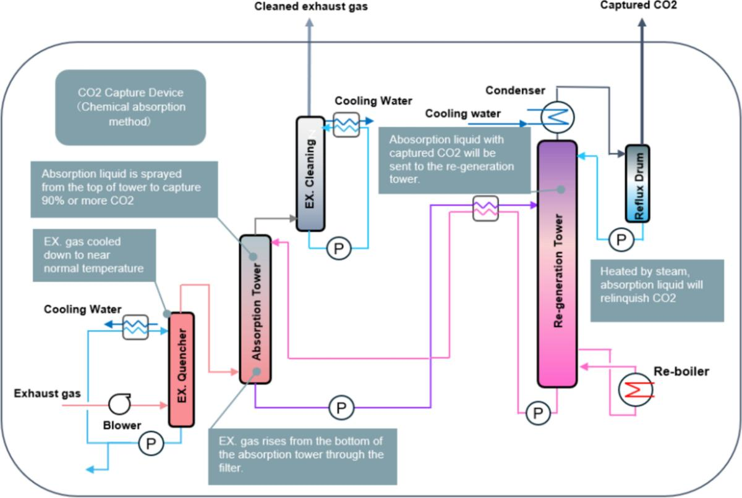
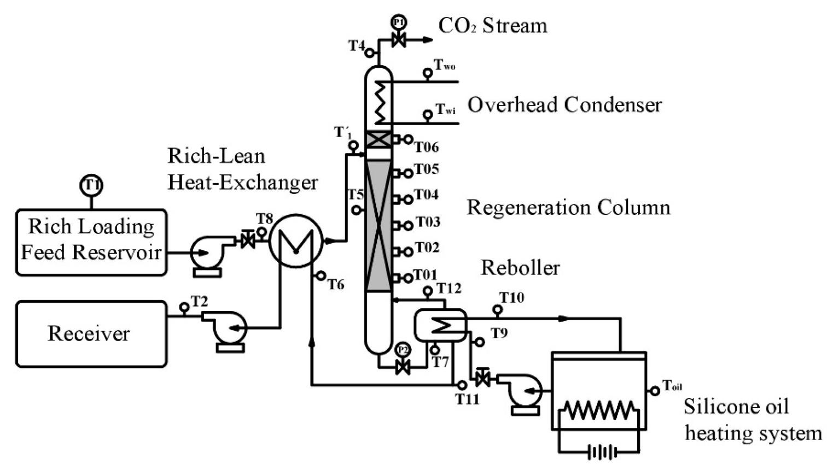

Equipment | Function
Exhaust gas conditioning unit | Cools and prepares exhaust gas for capture.
Absorber tower | Brings exhaust gas into contact with the solvent to remove CO₂.
Solvent regeneration unit | Uses heat to release the absorbed CO₂ and regenerate the solvent.
Heat exchangers and pumps | Transfer heat and circulate the solvent through the system.
CO₂ compressor | Raises the pressure of the recovered CO₂ for further processing.
CO₂ cooling and liquefaction unit | Prepares the CO₂ for storage and transport, where liquid storage is used.
Liquid CO₂ storage tanks | Store captured CO₂ under specified design conditions.
Control and safety systems | Monitor pressures, temperatures, flow rates, tank conditions, and abnormal operating conditions.
Additional equipment may include exhaust gas fans, filters, condensate-handling arrangements, gas detectors, pressure-relief devices, ventilation, and emergency shutdown systems.
5. Benefits and Technical Challenges
Potential benefits
- Reduces the quantity of CO₂ released directly from exhaust gas.
- May be retrofitted to suitable existing vessels.
- Complements engine-efficiency improvements and waste-heat recovery.
- Provides an additional decarbonisation option for ships using conventional fuels.
Technical and operational challenges
- Additional energy is required for solvent regeneration, compression, cooling and liquefaction.
- Extra machinery and CO₂ tanks occupy valuable space and add weight.
- Installation and maintenance costs can be high.
- CO₂ handling introduces specific pressure, ventilation, asphyxiation and cryogenic or cold-liquid hazards, depending on the system.
- Suitable shore-side reception, transport and storage infrastructure must be available.
- The net emissions benefit depends on capture performance, additional fuel consumption, and the final destination of the CO₂.
Studies and demonstrations indicate that onboard carbon capture is technically feasible, but commercial viability depends on the ship's operating profile, capture rate, energy penalty, installation cost, and available CO₂ infrastructure.
6. Important Distinction for Marine Engineers
CCS must not be confused with other exhaust emission-control systems.
SCR — Selective Catalytic Reduction
Primarily reduces nitrogen oxides (NOx) by converting them into nitrogen and water using a reducing agent, commonly urea solution.
Exhaust gas scrubber
In marine applications, commonly removes sulphur oxides (SOx) from exhaust gas to help meet applicable sulphur-emission requirements. Some designs also remove particulate matter.

CCS — Carbon Capture and Storage
Captures CO₂ after it has been produced during combustion, then prepares it for storage or subsequent handling.
Key engineering principle: CCS does not prevent CO₂ from forming during combustion. It separates and captures some of the CO₂ after its formation. It is therefore different from improving combustion efficiency, although both approaches may be used together.
7. Why CCS Is Important for Existing Ships
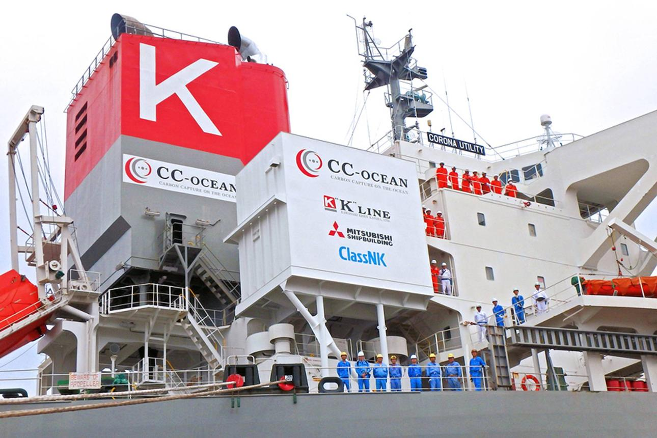

One potential advantage of onboard CCS is that it could reduce emissions from an existing vessel without requiring the immediate replacement of its main engine or fuel system.
However, a retrofit feasibility study must consider:
- Available engine-room and deck space.
- Additional weight, stability and structural loading.
- Electrical power and heat requirements.
- Main-engine exhaust flow and temperature across the operating range.
- Capture plant operation during manoeuvring, port stays and variable engine loads.
- CO₂ tank capacity, voyage duration and unloading frequency.
- Crew training, maintenance, safety management and applicable class and flag requirements.
For marine engineers, the key question is not simply whether CO₂ can be captured. It is whether the system can operate safely and reliably without an unacceptable reduction in vessel performance, cargo capacity or operational availability.

8. Practical Example: Calculating CO₂ Capture
Consider a hypothetical vessel that produces 100 tonnes of CO₂ over a particular operating period.
Illustrative example — assuming a 70% capture rate
CO₂ produced
100 t
CO₂ captured
70 t
CO₂ not captured
30 t
Capture rate
70%
The calculation is:
CO2 Captured = 100 X 70/100= 70 tons
CO2 Uncaptured= 100-70 = 30 tons
This example excludes additional emissions resulting from the energy consumed by the capture plant. The actual net reduction in greenhouse-gas emissions may therefore be lower than the nominal capture rate suggests.

9. Conclusion
The IMO's 2023 greenhouse-gas strategy established the ambition of net-zero greenhouse-gas emissions from international shipping by or around 2050, together with interim checkpoints for 2030 and 2040. CCS is one of several technologies being investigated to support maritime decarbonisation.
CCS is not a universal replacement for alternative fuels, energy-efficient engines, operational improvements or other emission-reduction technologies. Its contribution depends on the technical suitability of the vessel and the availability of a complete CO₂ handling and storage chain.
In simple terms: Improving engine efficiency reduces the amount of fuel burned. CCS attempts to capture some of the CO₂ that is produced when that fuel burns.
For marine engineers, the ultimate objective is to evaluate both the emissions reduction and the practical consequences for fuel consumption, machinery operation, safety, vessel capacity and operating cost.

