Hydrogen as a Marine Fuel: Why It Has Not Yet Become a Regular Fuel and What New Technologies Are Being Developed
Hydrogen is considered one of the potential future fuels for the shipping industry, particularly as the industry moves towards reducing greenhouse gas emissions. However, hydrogen is not yet a practical, large-scale replacement for conventional marine fuels such as VLSFO, MGO and LNG across the global merchant fleet. Because Hydrogen is called an energy carrier (similar to electricity) rather than a primary energy source because free, burnable hydrogen does not naturally exist in large quantities on Earth.
The main difficulty is not that hydrogen cannot produce power. Hydrogen can be used in internal combustion engines and fuel cells. The real challenge is producing it economically, storing sufficient quantities onboard, handling it safely, and supplying it through a reliable bunkering network.
From a marine engineering perspective, hydrogen presents challenges in fuel storage, combustion, machinery design, safety systems, vessel stability, operating cost and availability.

- Why has hydrogen not been widely used onboard ships until now?

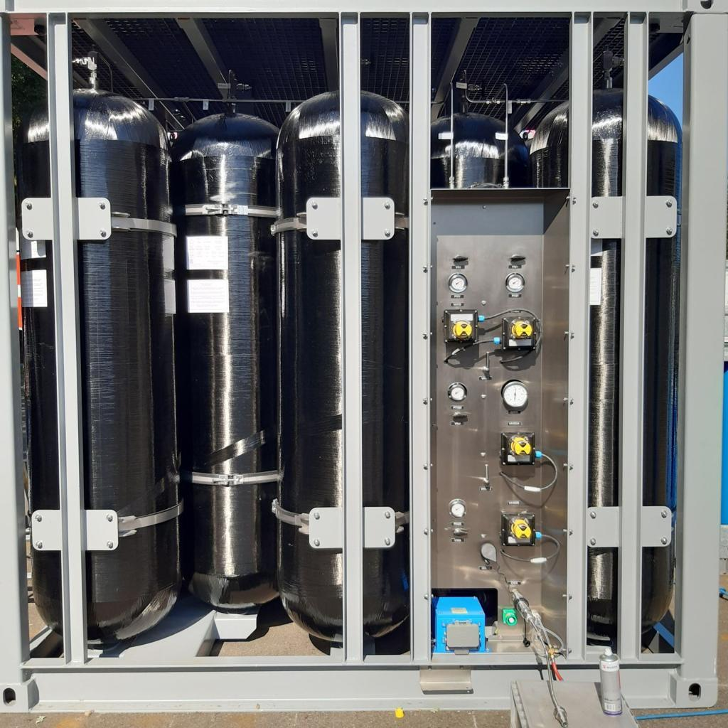
1. Very low volumetric energy density
Hydrogen contains considerable energy by mass, but it occupies a very large volume. Even when compressed or liquefied, it generally requires much more storage space than conventional marine fuel for the same energy output. This is a major disadvantage for long-distance cargo ships.
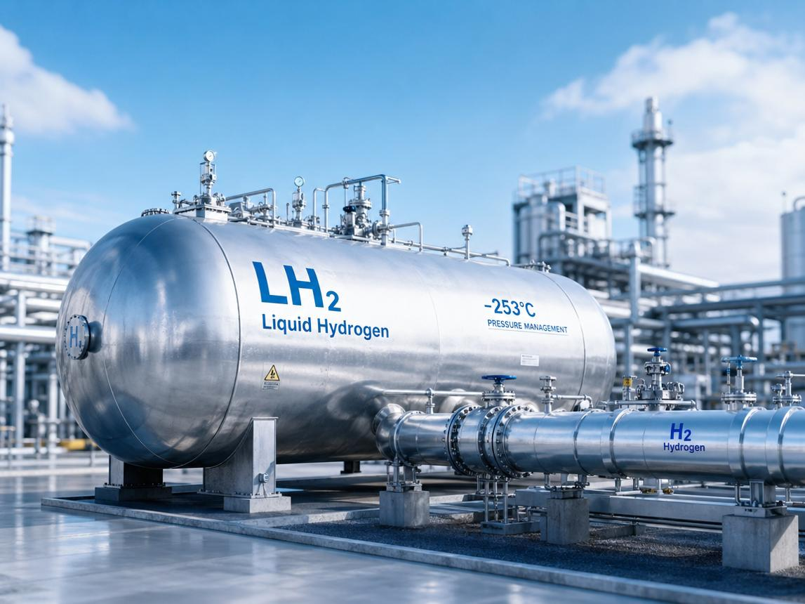
2. Difficult storage conditions
Hydrogen can be stored as compressed gas, typically at 350–700 bar in many applications, or as liquid hydrogen at approximately −253°C. Both methods require specialised equipment. Liquid hydrogen needs highly insulated cryogenic tanks and careful management of boil-off gas.
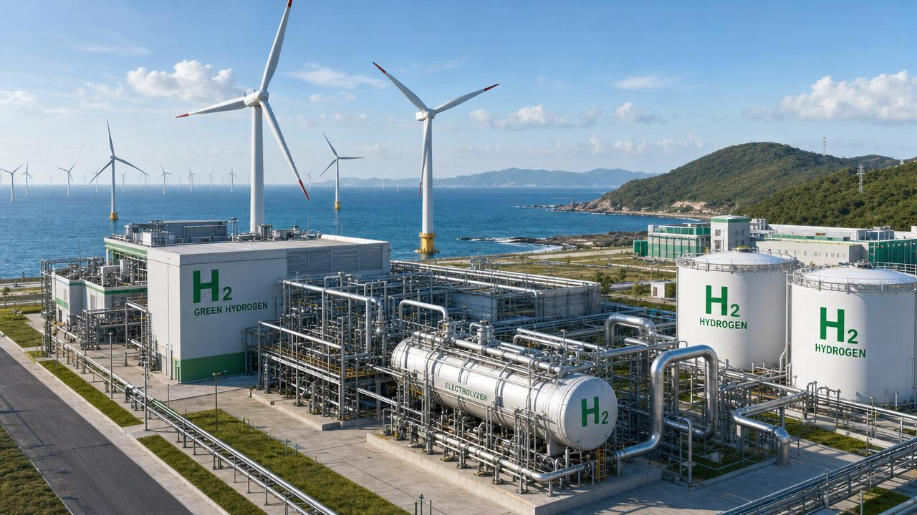
3. High production cost
Green hydrogen is produced by splitting water using electricity from renewable sources. Electrolysers, renewable electricity, compression, liquefaction and transportation all add cost. Fossil-fuel-derived hydrogen can be cheaper in some markets, but its overall climate benefit depends on production emissions and carbon capture performance.
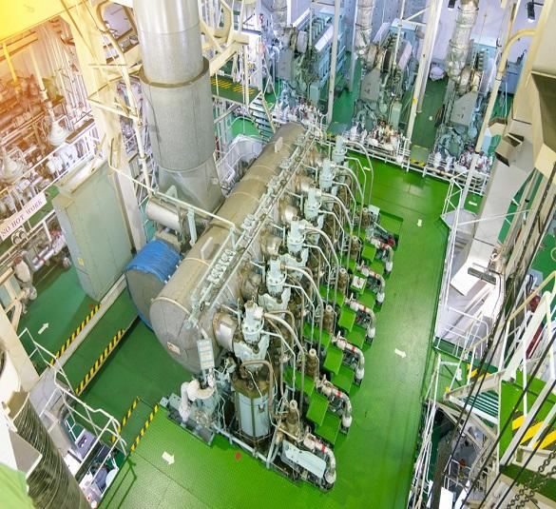
4. Existing marine engines are designed for other fuels
Most merchant vessels use diesel engines designed for liquid marine fuels. Hydrogen needs specially designed combustion systems or fuel cells, together with new fuel supply, ventilation, detection, control and shutdown arrangements. Retrofitting an existing vessel can therefore be expensive and technically complex.
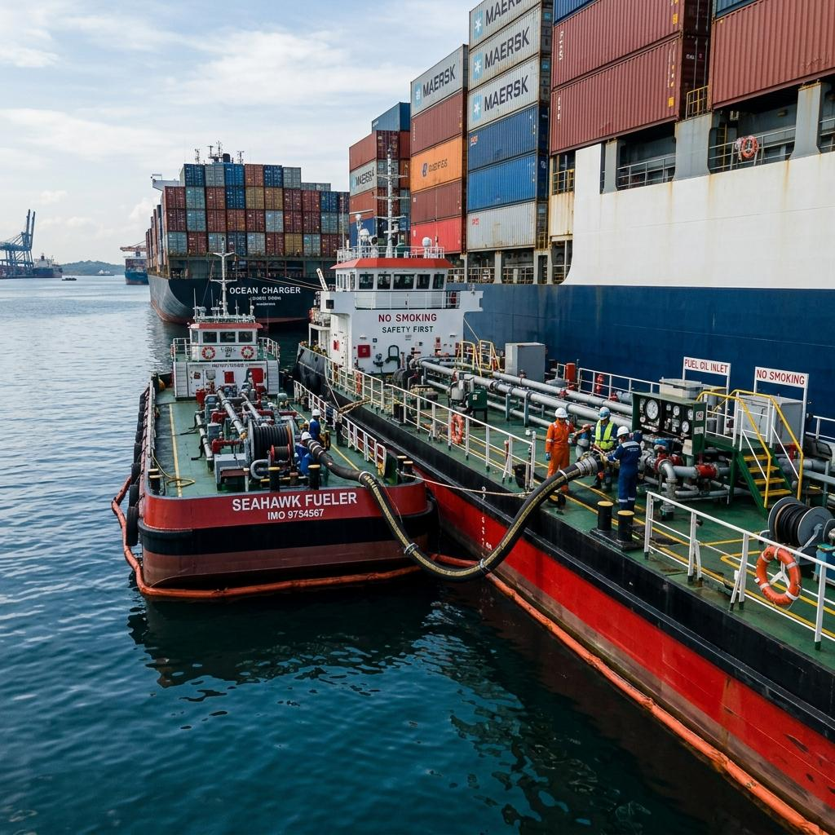
5. Limited bunkering infrastructure
Ships need dependable fuel supplies at their operating ports. Hydrogen production, transport, storage and ship-bunkering facilities are not yet available at the scale and geographic coverage of conventional marine fuels.
An important distinction: hydrogen is already used in industrial applications and is being used or tested in selected marine applications. The issue is its limited commercial adoption as the principal fuel for large, ocean-going merchant ships.
2. What are the major technical problems associated with hydrogen fuel?
From a Chief Engineer's point of view, the following are the principal issues that must be addressed before hydrogen can be used routinely onboard commercial ships.

A. Storage volume and energy density
The following comparison illustrates the fundamental problem.
Fuel | Approximate energy by mass | Storage considerations
Marine diesel / MGO | 42–43 MJ/kg | Ambient-temperature liquid storage
LNG | 48–50 MJ/kg | Cryogenic storage at about −162°C
Hydrogen gas | 120 MJ/kg | Requires high-pressure storage
Liquid hydrogen | 120 MJ/kg | Requires cryogenic storage at about −253°C
These are approximate lower-heating-value figures; actual system performance depends on the equipment and storage conditions.
Although hydrogen has nearly three times the energy per kilogram of diesel, its density is extremely low. The advantage in mass is therefore offset by the large tank volume and the weight of the storage equipment.
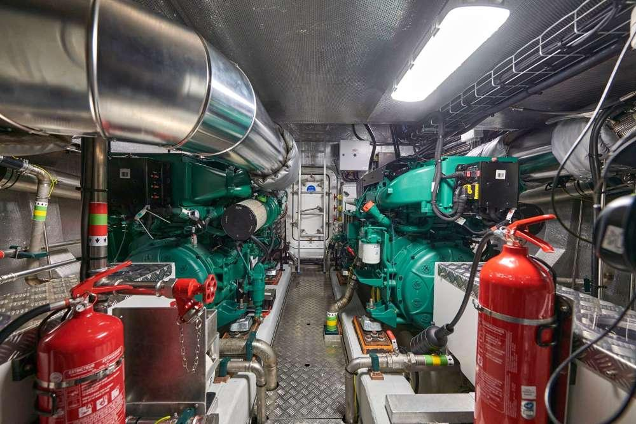
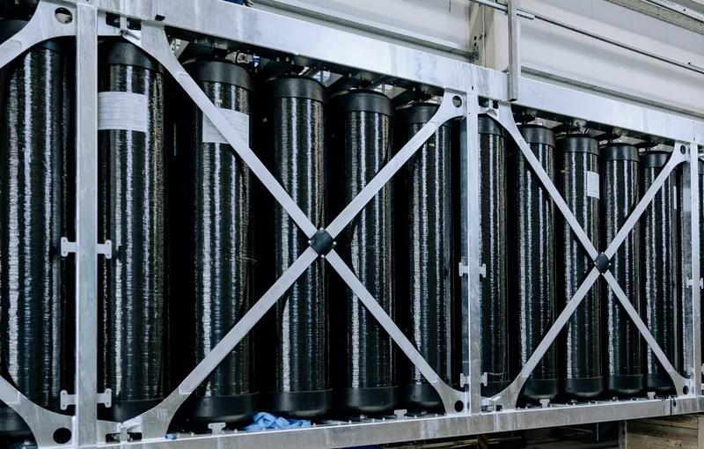

Practical implication: A ship designed for long voyages needs to reserve substantially more space for hydrogen storage than for conventional fuel. This reduces the space available for cargo, accommodation or other equipment.
The actual penalty depends on whether hydrogen is stored as compressed gas or liquid, the tank design, insulation, and the fuel-cell or engine efficiency.
B. Hydrogen leakage and fire hazards
Hydrogen is a small molecule that can escape through inadequately designed seals, joints, valves and connections. Its physical properties create several specific hazards:
- Wide flammability range: Hydrogen can burn in air over a broad range of concentrations, approximately 4–75% by volume under normal conditions.
- Low ignition energy: A small spark or electrostatic discharge can ignite a flammable mixture.
- Nearly invisible flame: Hydrogen flames can be difficult to see in daylight, requiring appropriate flame-detection equipment.
- Rapid dispersion: Hydrogen rises rapidly in open spaces, but it can accumulate in enclosed or poorly ventilated spaces, particularly near overhead structures.
- Leakage and material compatibility: Some metals can suffer hydrogen embrittlement, while seals and other components must be selected for hydrogen service.
Consequently, a hydrogen-fuelled vessel requires specialised gas detectors, ventilation, flame detection, emergency shutdown valves, pressure-relief arrangements, hazardous-area controls and carefully designed piping.
The fuel system must also prevent hydrogen from entering the engine room, accommodation or other enclosed spaces. Double-walled piping and safe venting arrangements are important design considerations.

C. Combustion problems in internal combustion engines
Hydrogen can be burned in a specially designed marine engine, but it cannot simply be substituted for diesel in an existing engine.
Technical problem | Engineering significance
Pre-ignition | Hydrogen may ignite before the intended ignition event.
Backfire and flashback | The flame may travel back towards the intake or fuel system if the engine design and controls are unsuitable.
Knocking and abnormal combustion | Uncontrolled combustion can cause excessive pressure and damage engine components.
NOx emissions | High combustion temperatures can produce nitrogen oxides even though hydrogen contains no carbon.
Power density | The gaseous fuel and its delivery arrangement can affect the air available for combustion and engine output.
The engine manufacturer must develop suitable injection, ignition, combustion-chamber geometry, air management and electronic control strategies.
Selective catalytic reduction (SCR) or other exhaust-treatment systems may be needed to control NOx, depending on engine design and the applicable emission requirements.
Important: Burning pure hydrogen does not produce CO₂ from the fuel itself, but it does not automatically mean zero exhaust emissions. NOx can still be produced, and the total climate benefit depends on how the hydrogen is manufactured and delivered.
D. Problems with liquid hydrogen
Liquid hydrogen offers greater volumetric density than compressed hydrogen, but introduces another set of engineering difficulties.
- Tanks must maintain extremely low temperatures.
- Insulation and tank supports require specialised engineering.
- Heat ingress causes some liquid hydrogen to evaporate, creating boil-off gas.
- Tank pressure must be managed through suitable control and pressure-relief arrangements.
- Fuel transfer and bunkering require cryogenic-compatible equipment and strict procedures.
- Maintenance and emergency response require specialist training.
Unlike a conventional diesel settling tank, a liquid-hydrogen tank cannot simply be opened and cleaned using normal shipboard tank-cleaning procedures.
Boil-off management is particularly important when a vessel remains alongside, operates at low load or has a prolonged period without consuming its stored hydrogen.

E. Hydrogen production and the true environmental benefit
Hydrogen is an energy carrier, not a primary energy source. Energy must be used to produce it.
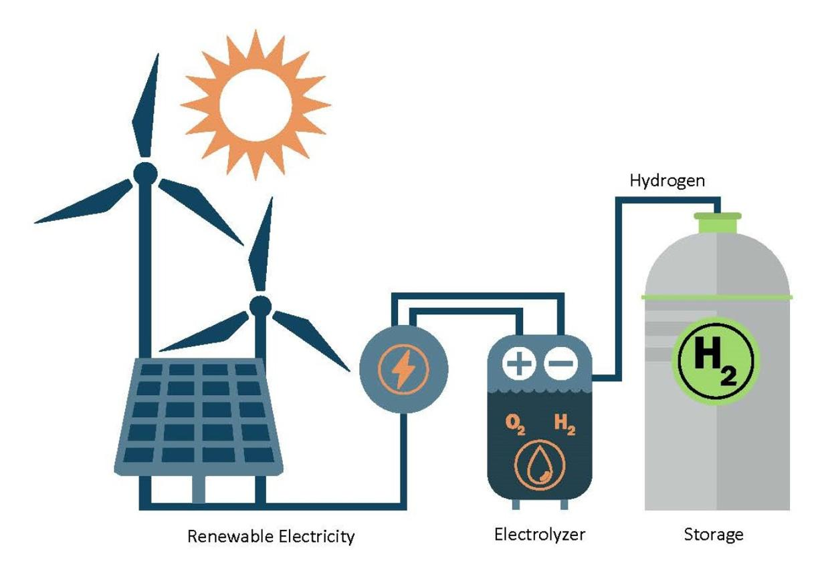
Green hydrogen
Water is split using renewable electricity in an electrolyser. This can provide very low lifecycle emissions when the electricity, equipment and supply chain are sufficiently low-carbon.
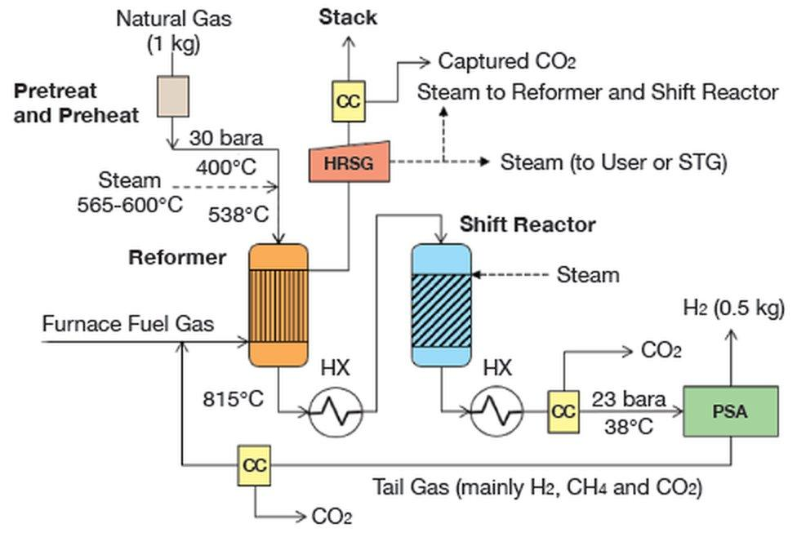
Grey hydrogen
Produced mainly from natural gas without capturing most of the associated CO₂. Its lifecycle emissions can be substantial.
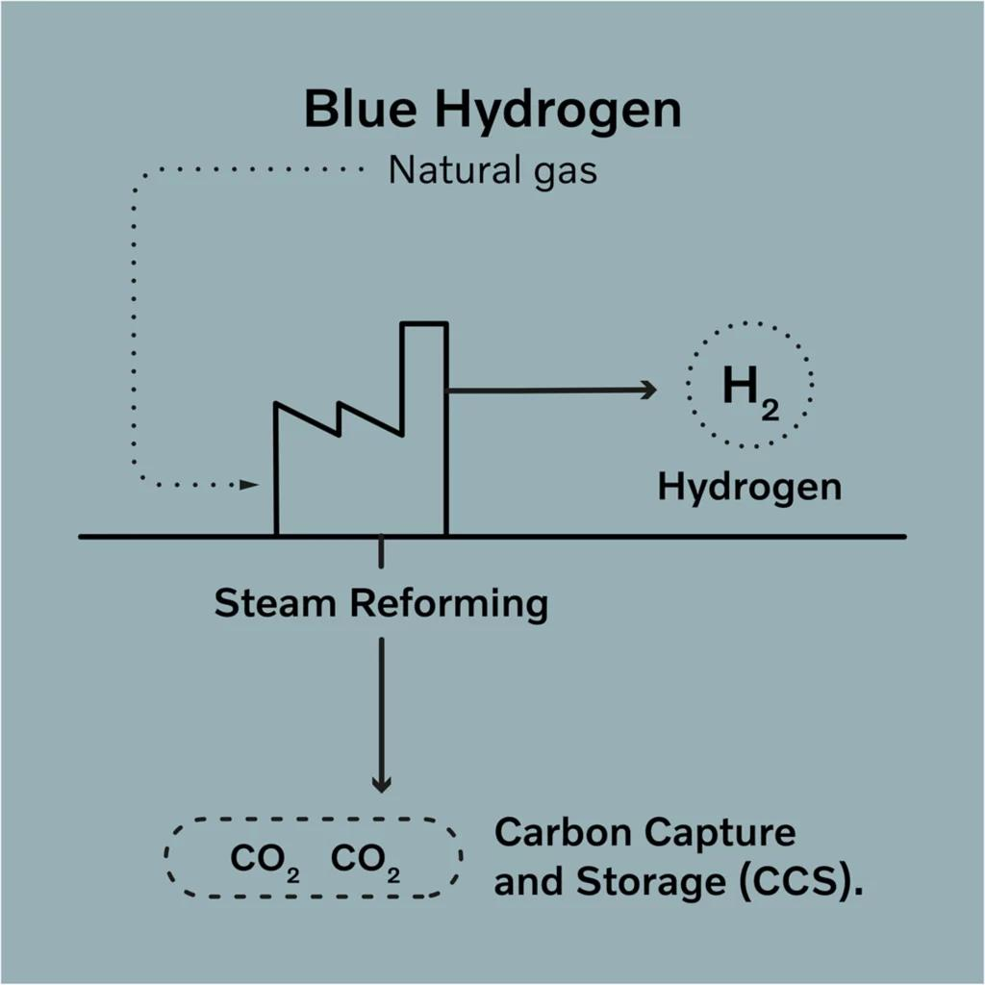
Blue hydrogen
Produced from fossil fuels with carbon capture and storage. Its climate benefit depends on capture rates, upstream methane leakage and other lifecycle emissions.
There are additional energy losses during electrolysis, compression or liquefaction, transport, and conversion back into useful power. As a result, renewable hydrogen can be expensive compared with directly using renewable electricity wherever batteries or shore power are practical.
3. What new technologies are being developed to make hydrogen a regular marine fuel?
The industry is working on several different approaches. Some are already at demonstration or type-approval stage, while others are planned for future vessel installations.
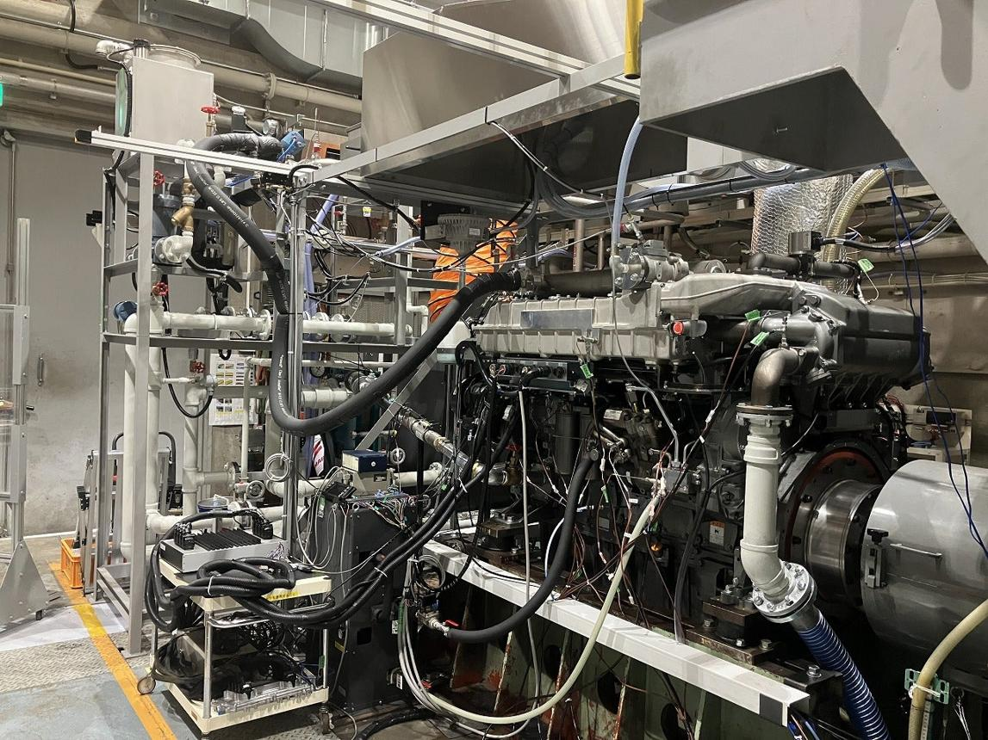
Technology 1 — Hydrogen-fuelled marine engines
Manufacturers are developing engines designed specifically to burn hydrogen, including medium-speed four-stroke engines and low-speed two-stroke engines intended for commercial vessels.
The objective is to retain the familiarity of engine-based propulsion while developing hydrogen-specific injection, combustion control and exhaust-treatment systems.
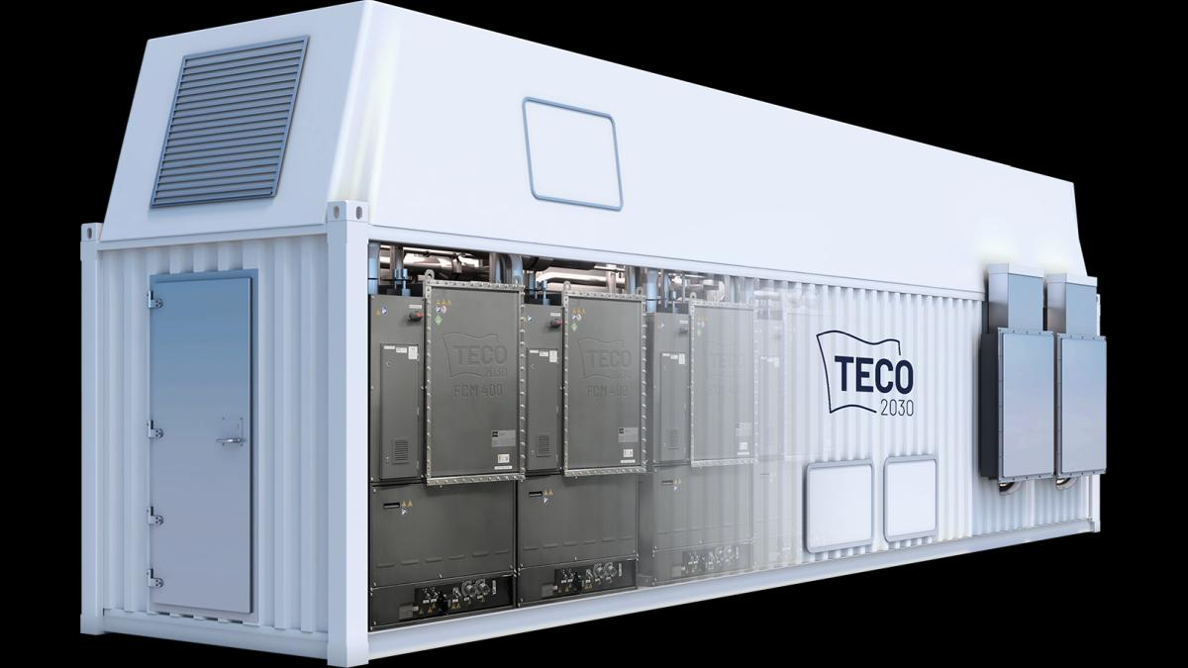
Technology 2 — Hydrogen fuel cells
A fuel cell converts hydrogen's chemical energy directly into electricity through an electrochemical reaction. The main products in a pure-hydrogen fuel cell are electricity, heat and water.
Fuel cells are particularly attractive for ferries, small vessels, harbour craft and vessels with electric propulsion. They can also supply electrical power to larger ships as part of a hybrid system.
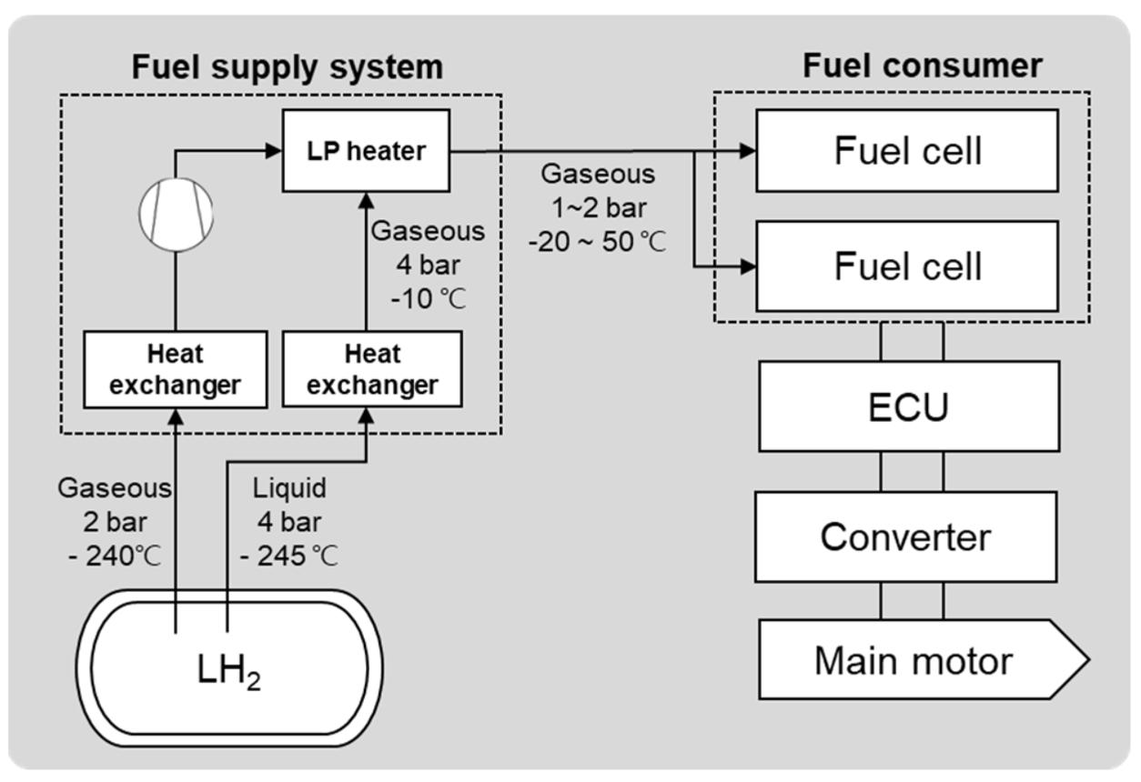
Technology 3 — Improved liquid-hydrogen fuel supply systems
Engineers are developing integrated systems for cryogenic storage, pumping, vaporisation where required, pressure control, fuel conditioning, double-walled piping, gas detection and bunkering.
Reliable fuel supply is as important as engine development. A successful engine demonstration alone does not establish that an entire vessel can operate safely and economically.
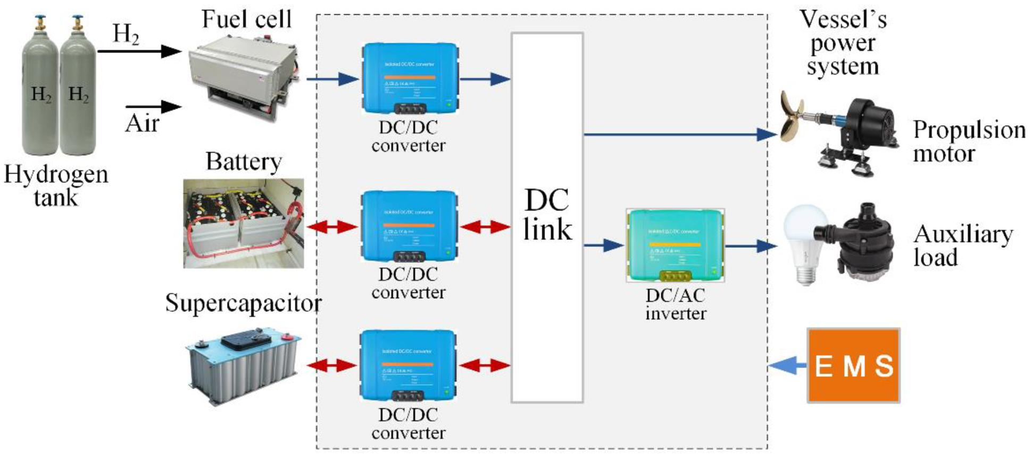

Technology 4 — Hybrid propulsion and energy management
Hydrogen fuel cells or engines can be combined with batteries, electric motors and conventional generators. Batteries absorb sudden load changes, support peak power and can improve operation at variable loads.
This is useful for vessels with variable electrical demand, dynamic positioning, frequent manoeuvring or low-speed operation.
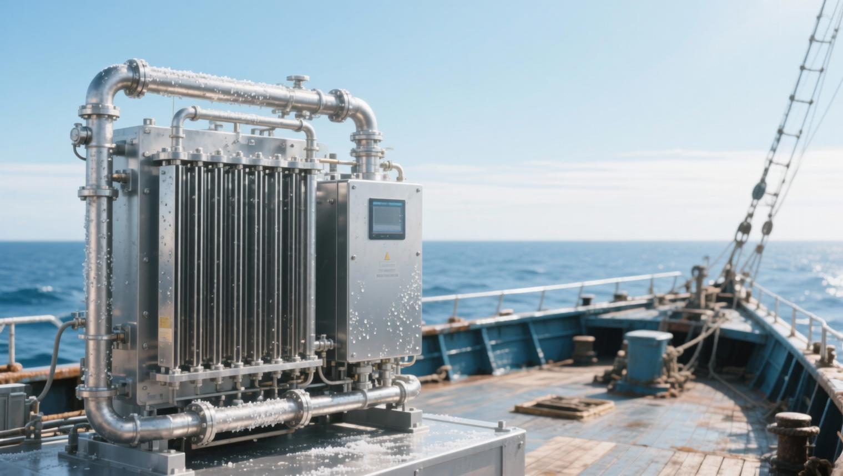
Technology 5 — Onboard hydrogen generation
Systems are being explored to produce hydrogen onboard from other fuels or feedstocks, including methanol and ammonia, using reforming or cracking processes.
This could reduce the need to bunker pure hydrogen directly, but it introduces conversion equipment, energy consumption, heat requirements and additional safety considerations. Hydrogen made from fossil-based feedstocks is not automatically zero-carbon.
Lloyd's Register published dedicated guidance on onboard hydrogen generation in February 2026, reflecting the need for clear technical requirements as these systems develop.

4. Latest real-world developments in hydrogen marine technology — 2025–2026
The following developments show that hydrogen is moving beyond laboratory research, although commercial deployment is still at an early stage.
Major engine milestone

Japan: Large commercial marine hydrogen engine
18 September 2026
Japan Engine Corporation, Kawasaki Heavy Industries, Yanmar Power Solutions, Mitsui O.S.K. Lines and other partners announced successful land-based testing of a hydrogen-fuelled engine intended for large commercial vessels. The project reported greenhouse-gas emissions reductions exceeding 95% compared with conventional heavy-fuel-oil engines under its stated comparison.
The planned next step is installation in a 17,500-DWT multipurpose vessel in January 2027, followed by sea trials and onboard demonstration testing expected to begin in April 2028. These are future milestones, not completed onboard trials.

Engine type approval
100% hydrogen engine approved by Lloyd's Register
17 June 2026
Lloyd's Register issued the first Type Approval Certificate for a 100% hydrogen-fuelled spark-ignited marine engine developed by BeHydro and Anglo Belgian Corporation. The engine is designed to operate entirely on hydrogen without requiring pilot fuel.
This is a significant certification milestone, but type approval does not by itself demonstrate widespread commercial operation across all vessel types.
Source: Lloyd's Register announcement
Japan: High hydrogen substitution in a marine engine demonstration
Reported 5 March 2026
A Japanese demonstration involving Yanmar Power Solutions achieved a hydrogen fuel substitution ratio of up to 96% under practical load conditions in a medium-speed, four-stroke engine test. The programme also addressed abnormal combustion control and NOx reduction using selective catalytic reduction.
This result demonstrates technical progress, but a high hydrogen substitution ratio in a test does not necessarily mean that every operating condition, lifecycle emission or commercial cost target has been achieved.

Norway: Liquid-hydrogen-powered bulk carriers under development
The NORDBULK project describes two planned 7,700-DWT bulk carriers for short-sea shipping. The proposed configuration includes 17 tonnes of liquid-hydrogen storage and 3.5 MW of PEM fuel-cell capacity.
This is an example of how a vessel can be designed around hydrogen from the beginning rather than trying to retrofit a conventional long-distance ship. The project is under development, so its stated design is not proof of completed commercial operation.

5. What safety regulations apply to hydrogen-fuelled ships?
The regulatory framework is developing alongside the technology. Shipowners cannot assume that a hydrogen installation can simply be approved under the rules used for conventional diesel engines.
Key considerations include:
- SOLAS: Ship safety, machinery installations, fire protection and emergency arrangements.
- IMO IGF Code and alternative-design provisions: The applicable regulatory route depends on the fuel system, vessel type and flag Administration's acceptance.
- IMO hydrogen interim guidelines: The IMO's Sub-Committee on Carriage of Cargoes and Containers agreed on draft interim guidelines in September 2025, with approval planned for the Maritime Safety Committee in 2026. The precise approval status should be confirmed against the latest IMO instruments before a vessel design is finalised.
- Classification society approval: Class must review the fuel storage, piping, machinery, ventilation, detection, shutdown and risk-assessment arrangements.
- Crew competency and emergency procedures: Personnel require training in hydrogen properties, gas detection, leak isolation, fire response and cryogenic hazards where applicable.
The IMO's March 2026 regulatory mapping update confirms that hydrogen-specific regulatory provisions remain an area of development.

International Maritime Organization
Official reference: IMO GreenVoyage2050 — Alternative marine fuel regulatory status
6. Which types of ships are most suitable for hydrogen?
Hydrogen will not necessarily become the preferred fuel for every vessel. Its suitability depends on voyage distance, power demand, available tank space, operating profile and fuel availability.
Vessel type | Hydrogen suitability | Main consideration
Harbour craft and small workboats | Promising | Short routes and predictable refuelling
Ferries and short-sea vessels | Promising | Regular schedules and dedicated bunkering
Research vessels | Potentially suitable | Electrical loads, low-speed operations and emissions requirements
Offshore support vessels | Possible for selected designs | DP power demand, endurance and redundancy
Bulk carriers | Under development | Large energy requirements and cargo-space competition
VLCCs and long-distance tankers | Challenging in the near term | Very large fuel demand and long voyage endurance
Container ships on intercontinental routes | Challenging in the near term | High power demand and limited space for fuel storage
For a research vessel or DP2 offshore vessel, hydrogen fuel cells combined with battery storage could be attractive where electrical propulsion is already used. However, dynamic positioning requires reliable power availability, rapid load response and adequate redundancy. A hydrogen system would have to demonstrate that it can meet these requirements under the vessel's worst-case operating conditions.
For large tankers, a low-carbon liquid fuel, such as suitably sourced biofuel or e-methanol, or another alternative fuel may be easier to deploy in the nearer term, depending on engine technology and fuel availability.
7. When can hydrogen become a regular marine fuel?
There is no single date when hydrogen will become the standard marine fuel. Adoption is likely to occur in stages.
Stage 1 — Demonstration and certification (under way)
Marine hydrogen engines, fuel cells, storage systems and safety arrangements are being tested and certified.
Stage 2 — Early commercial deployment
Selected short-sea vessels, ferries, workboats and demonstration cargo ships may begin operating with dedicated hydrogen supply chains. Actual progress will depend on successful onboard trials and investment decisions.
Stage 3 — Broader commercial use (2030s and beyond, uncertain)
Wider use would require lower-cost low-carbon hydrogen, more bunkering terminals, proven equipment reliability, clear regulations and competitive lifecycle costs. Large deep-sea ships may take longer than short-sea vessels.
These are indicative development stages, not guaranteed industry deadlines.
8. Conclusion: Is hydrogen the future of marine propulsion?
Hydrogen has a genuine role in maritime decarbonisation, but its success will depend on the entire fuel chain, not merely the engine.
The most important technological advances are:
- Marine engines designed to burn 100% hydrogen.
- More efficient fuel cells and hybrid electric propulsion.
- Safer and more compact cryogenic storage and fuel-supply systems.
- Economical green-hydrogen production and reliable bunkering infrastructure.
- Approved safety standards, trained crews and proven onboard operating experience.
My technical assessment: Hydrogen is a promising option for selected short-sea, ferry, workboat and specialised vessel applications. For large ocean-going tankers and bulk carriers, the storage-volume penalty, cost and infrastructure requirements remain major barriers. Successful full-scale engine and vessel demonstrations will be essential before hydrogen can compete widely with other low-carbon marine fuels.
The key question is “Can we store, supply and use enough low-carbon hydrogen safely and economically to complete the entire voyage?”

