Present-Day Bunkering Fuel Issues and Types of Marine Fuels Used Onboard Ships
For today's shipboard operations, bunkering is no longer simply a matter of receiving fuel and transferring it to storage tanks. Chief Engineers must consider fuel quality, compatibility, MARPOL compliance, engine performance, safety, emissions regulations, and the availability of alternative fuels.
The following is a practical technical overview relevant to Chief Engineers, Technical Superintendents, and ship management companies.
1. Various types of marine fuels used onboard ships
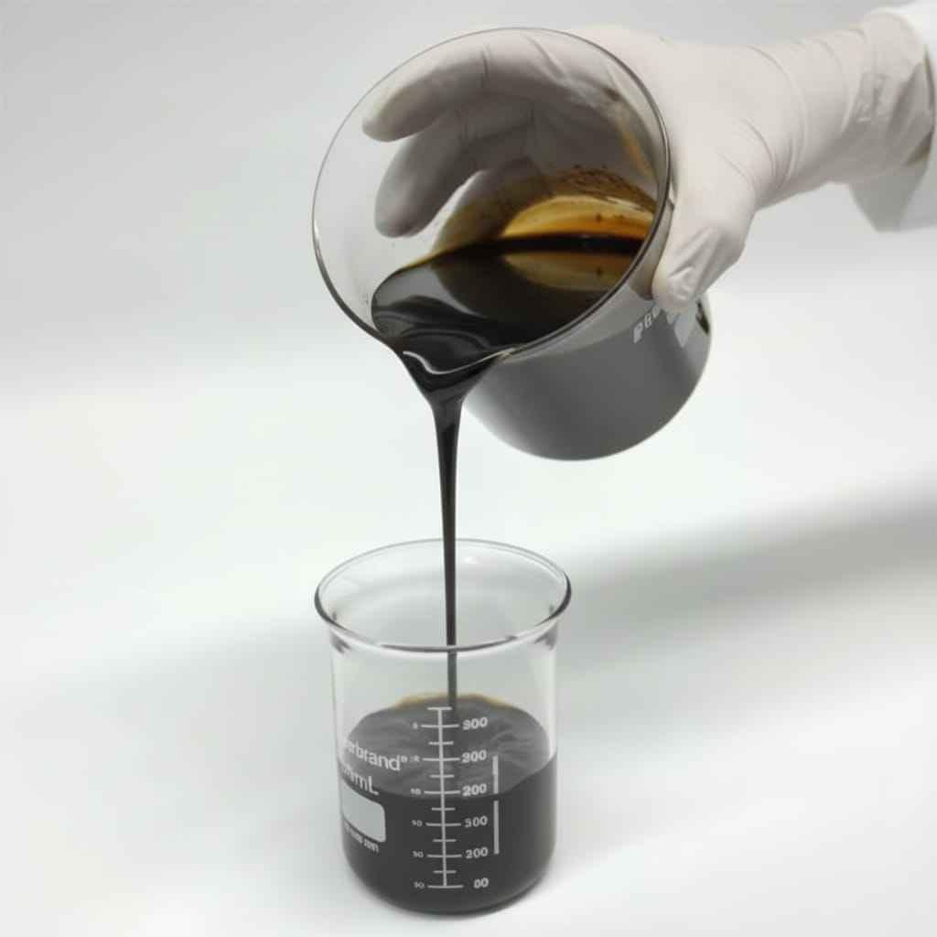
1. Heavy Fuel Oil (HFO) / Residual Fuel
- Mainly used on large ocean-going vessels equipped with fuel heating and treatment systems.
- Requires heating, settling, centrifuging, and viscosity control.
- presently used with exhaust gas cleaning systems (scrubbers) where applicable to meet sulphur requirements.
- Main risks: catalytic fines (Al + Si), sludge, high viscosity, incompatibility, and purifier overload.
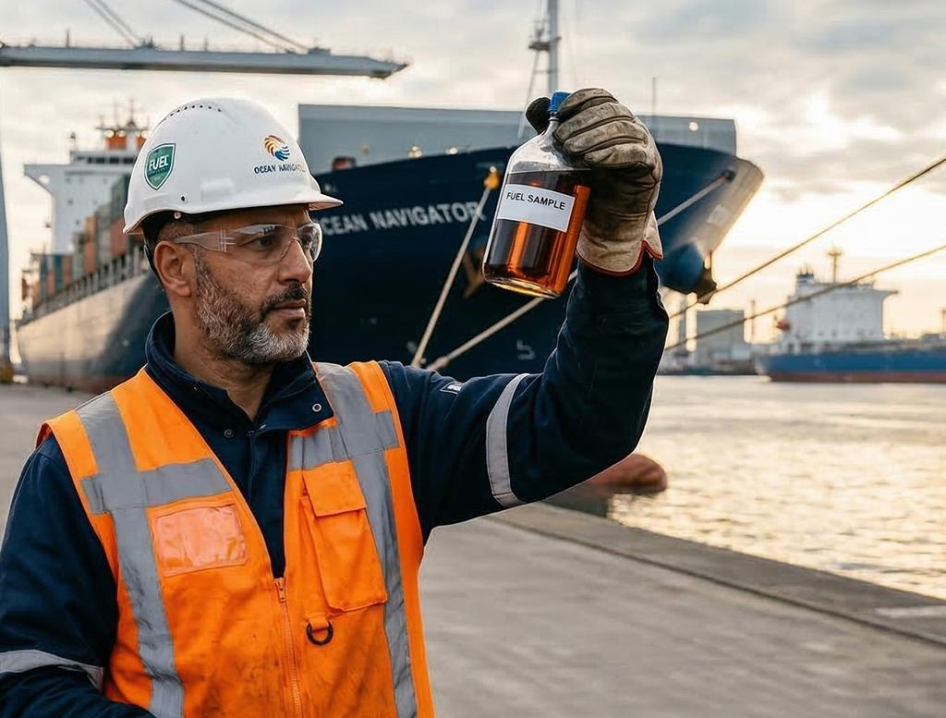
2. Very Low Sulphur Fuel Oil (VLSFO)
- Widely used to comply with the IMO global sulphur limit of 0.50% m/m.
- Often a blended fuel with variable properties between suppliers and batches.
- Main risks: incompatibility, sediment formation, stability problems, abnormal viscosity, and ignition or combustion difficulties.
- Particular attention is required when changing between different bunker batches.
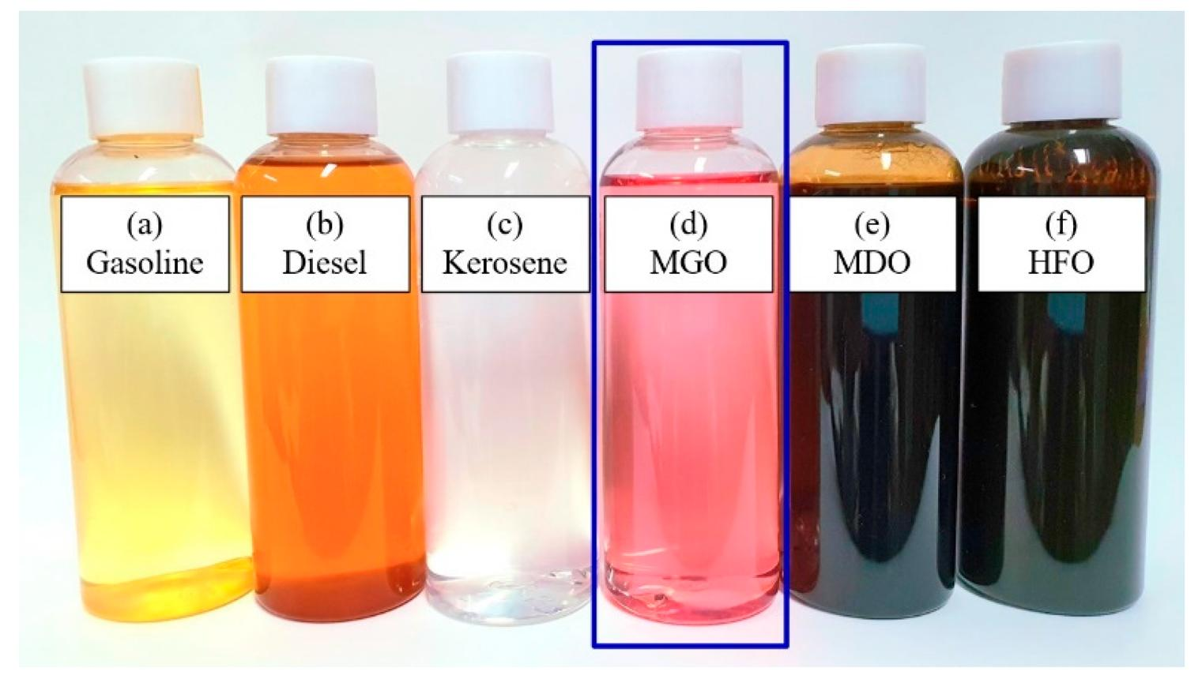
3. Marine Gas Oil (MGO) / Marine Diesel Oil (MDO)
- Distillate fuels used in auxiliary engines, boilers, and main engines according to engine design and fuel specifications.
- MGO is generally a distillate fuel; MDO may have different formulations and residual content.
- Commonly used in emission control areas (ECAs), subject to the applicable sulphur limit.
- Main risks: low lubricity, fuel-system leakage due to lower viscosity, water contamination, and thermal shock during changeover.
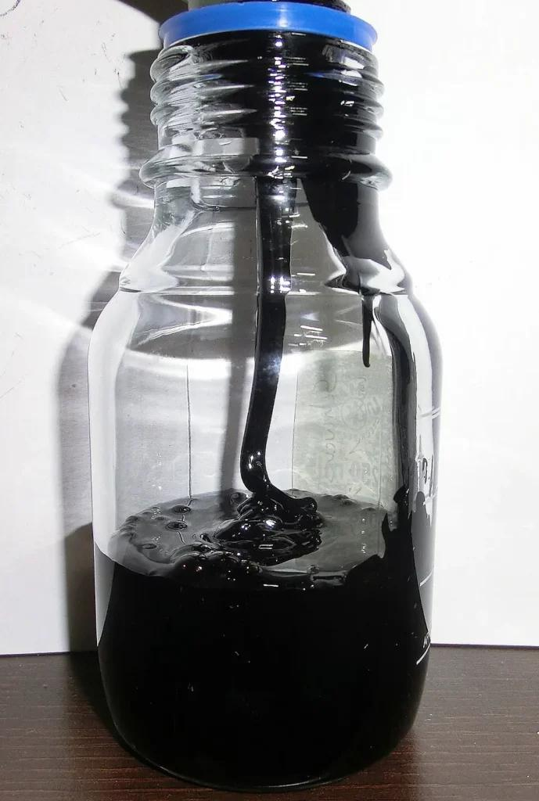
4. Ultra-Low Sulphur Fuel Oil (ULSFO)
- A fuel category generally associated with sulphur content at or below 0.10% m/m.
- Used where the applicable regulations require a 0.10% sulphur limit.
- Can be distillate-based or formulated as a low-sulphur fuel blend.
- Main risks: incompatibility with the fuel already in the system, viscosity changes, and insufficient lubricity depending on formulation.
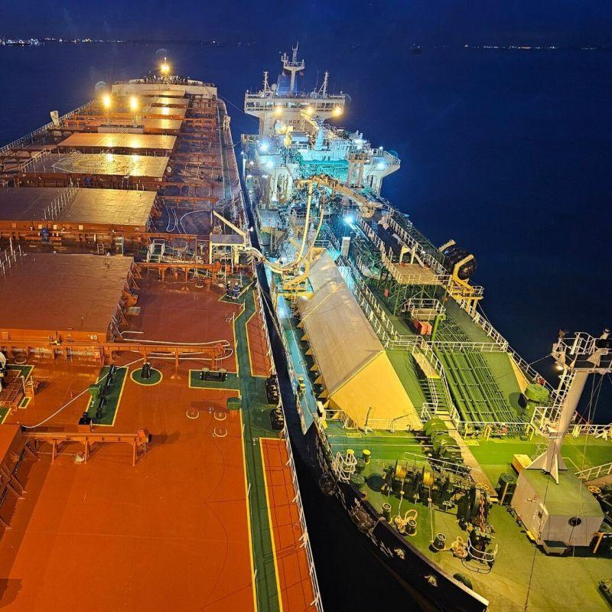
5. Liquefied Natural Gas (LNG)
- Used in dual-fuel engines, gas engines, and some boiler installations.
- Can significantly reduce SOx and particulate emissions; CO₂ emissions and methane slip depend on engine technology and operating conditions.
- Requires cryogenic storage, gas detection, and specialised bunkering arrangements.
- Main risks: cryogenic burns, gas leaks, fire or explosion, and methane slip.
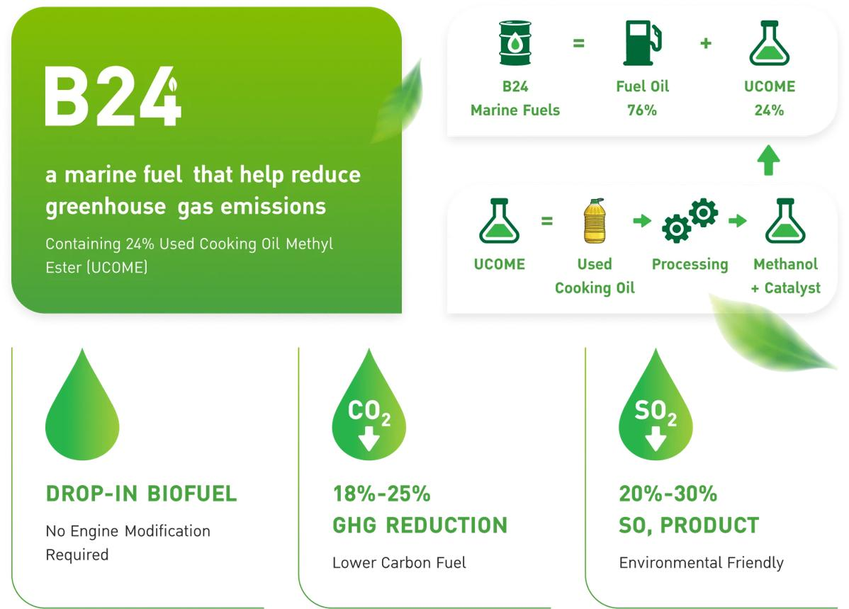
6. Marine Biofuels and Biofuel Blends
- Examples include B24, containing nominally 24% FAME biodiesel blended with conventional marine fuel, subject to the specific product specification.
- Can potentially be used in existing engines with suitable fuel approval, handling arrangements, and risk assessment.
- Main risks: oxidation, water affinity, microbial growth, cold-flow problems, storage stability, and compatibility.
- Confirm the actual blend, specification, and OEM acceptance before use.
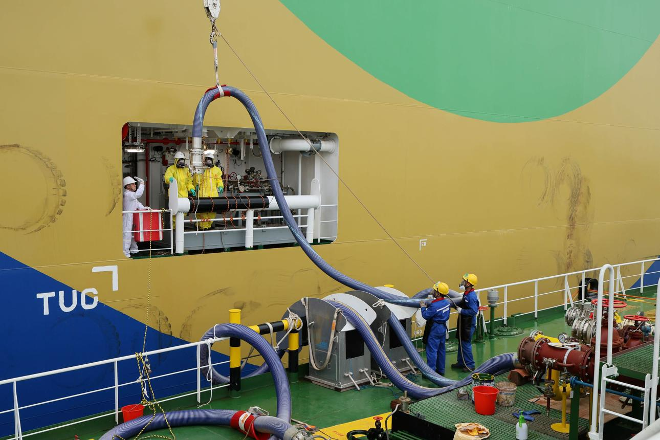
7. Methanol
- Used in specially designed methanol-capable engines and dual-fuel vessels.
- Liquid storage is easier than LNG storage, but methanol is toxic, flammable, and has a relatively low flash point.
- Requires suitable fuel-system materials, ventilation, leak detection, and protective arrangements.
- Renewable or low-carbon methanol may reduce lifecycle emissions depending on how it is produced.
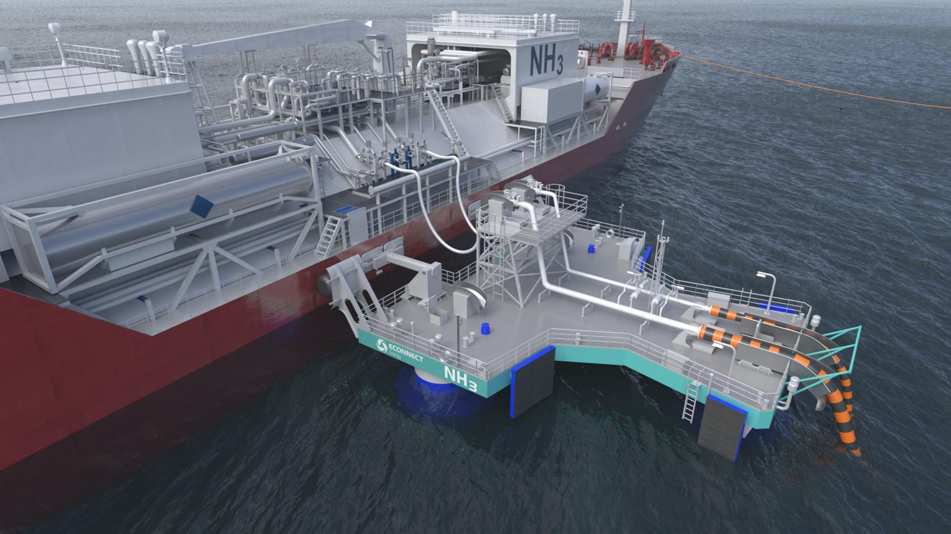
8. Ammonia
- An emerging alternative fuel for specially designed marine engines and fuel systems.
- Contains no carbon, so its combustion does not directly produce CO₂ from the fuel itself.
- Main challenges: high toxicity, corrosiveness in some conditions, combustion characteristics, NOx and possible N₂O emissions, and fuel-supply safety.
- Requires stringent leak detection, containment, emergency response, and crew training.
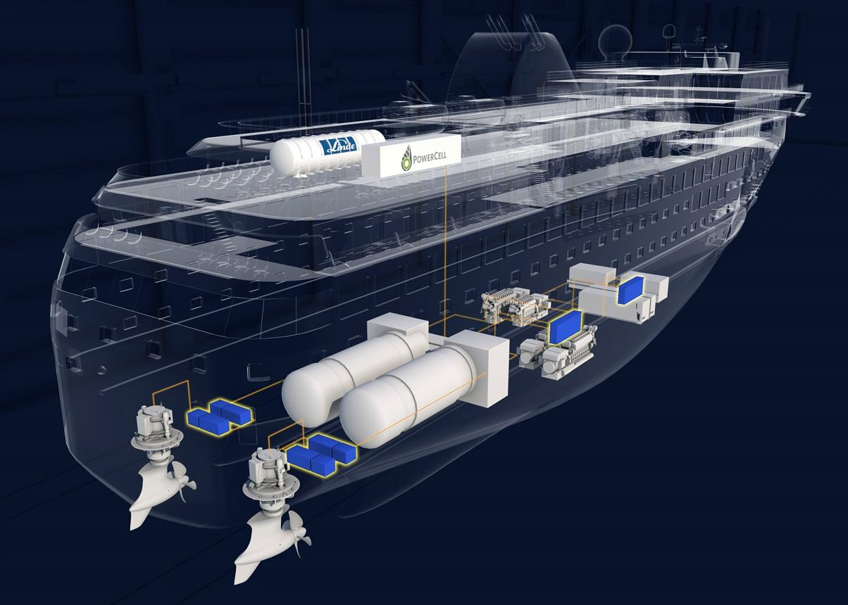
9. Hydrogen
- Being explored for fuel cells and specially designed combustion systems, particularly for selected short-sea and specialised vessels.
- Has no carbon in the fuel itself, but its overall emissions depend on production and supply.
- Main challenges: low volumetric energy density, storage, leakage, ignition risk, and bunkering infrastructure.
Other options include LPG, synthetic e-fuels, renewable diesel, and emerging methane-based fuels. Availability and practical suitability vary significantly by vessel type, route, engine design, and port infrastructure.
2. Major bunkering fuel issues faced by ships today
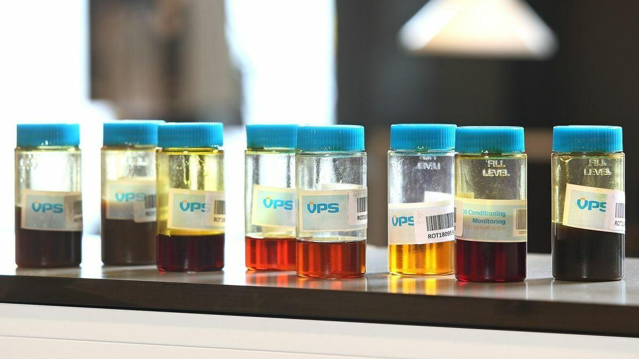
Issue 1 — Poor or off-specification bunker fuel
Fuel may meet the sulphur limit but fail other required quality parameters, such as viscosity, flash point, sediment, water content, or ignition quality. A compliant sulphur result alone does not establish that fuel is suitable for the engine.
Consequences: poor combustion, filter choking, fuel pump wear, engine instability, and potential machinery damage.
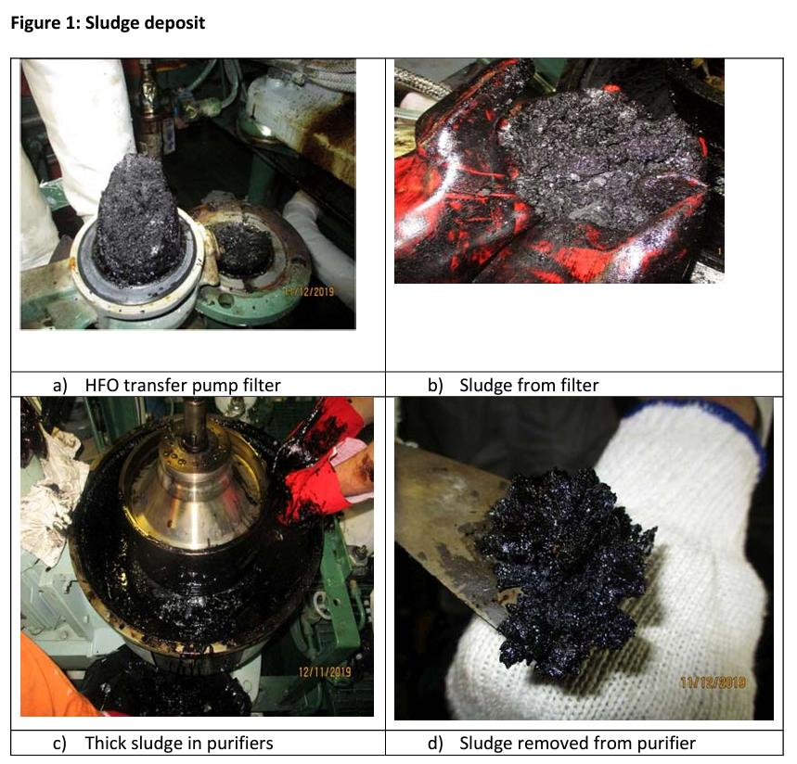
Issue 2 — Fuel incompatibility and sludge formation
Two individually acceptable fuels can be incompatible when mixed. Asphaltenes may precipitate, creating sludge that blocks filters and separators.
Consequences: rapid filter differential-pressure increase, fuel starvation, loss of engine power, and possible propulsion failure.
Control: segregate new bunkers wherever possible and perform a compatibility test before mixing.

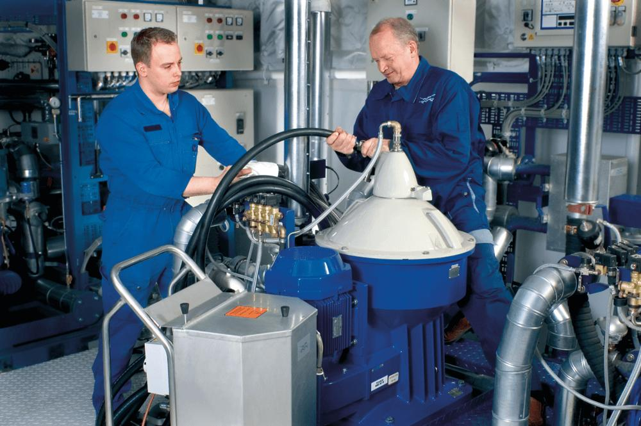
Issue 3 — Catalytic fines (Aluminium and Silicon)
Cat fines are hard particles originating from refinery catalytic-cracking processes. If they pass through the fuel-treatment system, they can cause abrasive wear to fuel pumps, injectors, piston rings, and cylinder liners.
Control: verify laboratory results, optimise purifier temperature and throughput, maintain correct separator settings, and monitor filter differential pressure. Follow the engine maker's limits for fuel entering the engine.
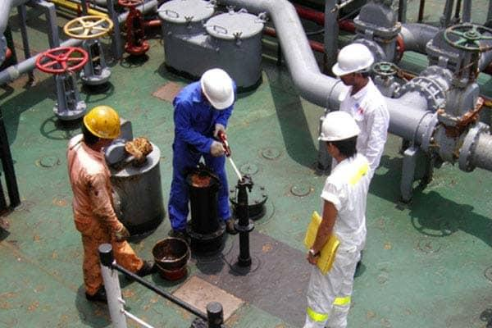
Issue 4 — Water contamination and excessive sediment
Water may enter through shore-side contamination, leaking tank heating coils, condensation, or inadequate fuel handling. Excessive sediment can overload treatment equipment.
Consequences: poor combustion, corrosion, separator malfunction, microbial growth in susceptible fuels, and filter blockage.
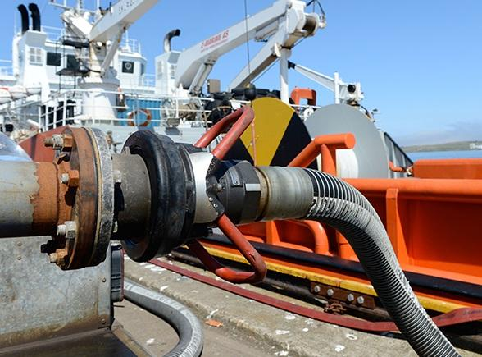
Issue 5 — Bunkering quantity disputes and measurement errors
The quantity recorded by the bunker supplier may differ from the ship's measured receipt due to temperature and density differences, meter errors, incorrect tank calibration, air in the delivery line, or inaccurate soundings.
Control: agree on the measurement method, check bunker delivery meter readings where applicable, record tank soundings and temperatures, monitor the transfer continuously, and reconcile delivered volume with mass using appropriate density and temperature corrections.
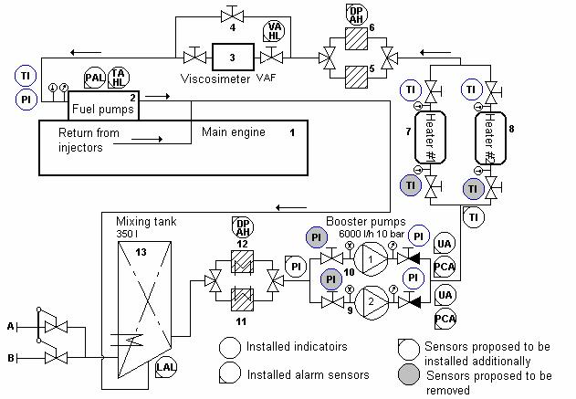
Issue 6 — Abnormal viscosity and temperature
Different VLSFO blends may have widely varying viscosity and cold-flow properties. Low-viscosity fuel can reduce the lubricating film in fuel pumps, while excessive heating can cause problems with some fuels.
Control: monitor viscosity at the engine inlet where applicable, adjust fuel temperature according to the engine maker's requirements, and check the fuel changeover procedure.
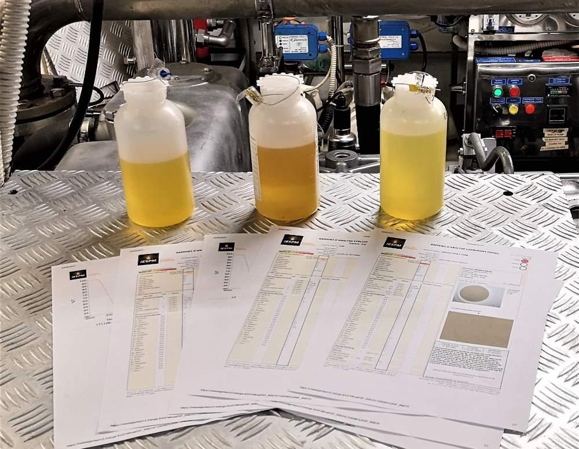
Issue 7 — Bunker sampling and documentation
Poor sampling practice can make it difficult to establish what fuel was actually delivered. Missing or inconsistent bunker delivery notes, sealed samples, and laboratory records can complicate regulatory inspections and commercial disputes.
Control: take the required representative sample at the agreed sampling point, use the prescribed procedure, seal and label samples correctly, and retain the MARPOL sample and bunker delivery note for the required periods.

3. Bunkering problems specific to modern and alternative fuels
Fuel type | Specific challenge | Main shipboard precaution
VLSFO | Compatibility, stability, sediment | Test compatibility; avoid unplanned mixing
MGO/MDO | Low viscosity, lubricity, temperature change | Check engine maker's limits and changeover procedure
Biofuel blends | Oxidation, water affinity, cold-flow properties | Check blend specification, storage conditions and OEM approval
LNG | Cryogenic hazards, gas leakage, methane slip | Gas detection, cryogenic PPE and approved bunkering procedures
Methanol | Toxicity, low flash point | Closed transfer, leak detection and suitable PPE
Ammonia | Severe toxicity and leakage hazards | Dedicated containment, detection and emergency arrangements
Hydrogen | Leakage, ignition and storage challenges | Purpose-designed storage, ventilation and safety systems
The IMO's March 2026 alternative-fuel regulatory mapping highlights that regulatory readiness differs between fuel types, with work continuing on some safety provisions. Ships must therefore assess the applicable rules and approved design before adopting a new fuel.

4. Correct bunkering procedure — Chief Engineer's checklist
Operational checklist
0 of 10 completed
Confirm the ordered grade, quantity, sulphur limit and fuel specification.
Review the bunker delivery plan, risk assessment, communications and emergency-stop arrangements.
Check tank capacity, available ullage, line-up, valve positions and segregation of incompatible fuels.
Verify the agreed sampling point, representative sampling arrangement and sealing procedure. Mostly on vessel bunker manifold
Conduct the pre-transfer safety meeting and test communications with the supplier.
Monitor transfer rate, tank levels, pressures, temperatures and leakage throughout bunkering.
Reconcile the delivered quantity against measurements and record any discrepancy before signing documents.
Obtain the bunker delivery note and sealed representative sample; retain records as required.
Send samples for laboratory analysis and review critical parameters before deciding on use.
Keep new fuel segregated where possible; test compatibility before commingling and update fuel-system procedures.
Copy checklist
Important: Do not rely solely on a supplier's certificate or a fuel's sulphur result. Assess fuel quality against the agreed specification, the applicable ISO 8217 grade, engine-maker requirements, and ship-specific procedures. ISO 8217:2024 is the seventh edition of the marine fuel specification standard.

5. Current marine fuel regulations — what the Chief Engineer must know
The main international requirements include MARPOL Annex VI, SOLAS fuel safety provisions, and the applicable marine fuel specification.
Requirement | Key point
Global sulphur limit | Maximum 0.50% m/m outside applicable stricter areas
Sulphur Emission Control Areas (SOx ECAs) | Generally 0.10% m/m
Fuel quality | Assess compliance with applicable ISO 8217 specification and agreed contractual requirements
Flash point | SOLAS generally requires fuel oil used onboard to have a flash point of at least 60°C, subject to specific provisions and exceptions
Bunker Delivery Note (BDN) | Retain for at least 3 years under MARPOL Annex VI
Representative MARPOL sample | Retain until the fuel is substantially consumed, and for at least 12 months after delivery
Alternative fuels | Check the applicable statutory requirements, class approval, flag requirements, and engine manufacturer's instructions

6. Emerging commercial challenges in 2026
- Fuel price uncertainty: differences in availability and pricing between conventional fuels and lower-carbon alternatives affect voyage economics.
- Alternative fuel availability: suitable fuels and bunkering infrastructure are not available in every port.
- Carbon intensity: ship operators increasingly need to consider lifecycle emissions and the requirements applicable to their trading routes.
- Regulatory uncertainty: the IMO's proposed global net-zero framework remains an important issue for future investment decisions. Reuters reported on 16 October 2026 that uncertainty over the framework was affecting demand for lower-carbon marine fuels.
7. My recommendation for a Technical Superintendent
For conventional tanker, bulk carrier, and offshore vessel operations, I would prioritise these five areas:
- Fuel quality management: laboratory analysis, supplier performance, and trend monitoring.
- Bunker quantity control: independent verification and accurate reconciliation of delivered quantities.
- Fuel segregation: compatibility testing and avoiding unnecessary commingling.
- Machinery protection: effective purification, filtration, temperature and viscosity control, and engine condition monitoring.
- Future fuel readiness: evaluate biofuel blends and alternative fuels only after assessing technical suitability, safety, statutory requirements, and commercial viability.
The key lesson is that a fuel can comply with the sulphur limit and still be unsuitable for a particular ship's machinery. Good bunker planning and disciplined onboard fuel management are essential to prevent engine damage, operational delays, and costly disputes.
Sources: International Maritime Organization guidance on sulphur limits and fuel oil availability and quality.


